10 min Fitness
Name: Target HR (10sec):
Round 1: (Warm Up) Do each exercise for 30seconds. Time will start when most people are ready to go. When we are finished we will check our heart rates.
Round 2: Do each exercise for 60seconds. Time will start when most people are ready to go. When we are finished we will check our heart rates.
NOTE: Do Side planks on each side for ½ the time given (15sec/30sec)
NOTE: Do as many as you can, or hold as long as you can, then rest for 10sec and continue.

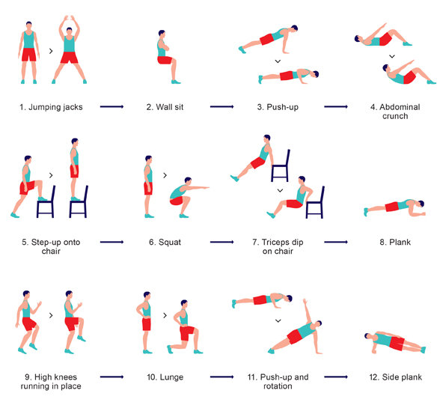
“Skipping”
Isometric Squat
Jump Lunge
Super Skaters
Burpees
Supermans
Military Push Up
Mountain Climbers
Twisting Plank

