Volleyball Assessment Ideas & Rules

Table of Contents
Ideas for Assessment Practices ……………. 1
Sample Volleyball Skills Assessment Design ……………. 2
Volleyball Skills Pre-Assessment Sheet …………….. 3
Volleyball Skills Final Assessment Sheet …………….. 4
Underhand Serve Pre & Final Assessment Sheet …………….. 5
Overhand Serve Pre & Final Assessment Sheet …………….. 6
Gr 6/7 Game Play Rubric Sheet …………….. 7
Gr 7/8 Game Play Rubric Sheet …………….. 8
Sample Volleyball Quiz Questions …………….. 9
Sample Volleyball Quiz Answer Key …………….. 12
Basic Volleyball Rules …………….. 15
Volleyball Hand Signals …………….. 16

Ideas for Assessment Practices
Teachers will choose to give their own weighting to each assessment and ultimately how they wish to assess their students. So, some may choose to use some, all, or none of the provided assessment materials or ideas. Example assessment materials can be found in this section (Appendix A.) The suggestions below are just some possible methods of using those assessment tools with possible rationales below.

- Consider using a pre-assessment of all of the skills in the first lesson, or as the skill is introduced. The assessment can be teacher or peer assessed.
  - Students would get to see the assessment activities and how they relate to all future activities throughout the unit, which would hopefully increase student focus
  - Through peer assessment students can develop their own observation skills as well as their ability to give feedback.
  - Sample assessment includes a self-reflection for students to develop their ability to reflect on their performance and set their own goals for the rest of the unit leading to greater ownership of their learning.

- Final skills assessment observations can be done by the teacher or student, depending on your confidence in their observation skills.
  - May go through practice assessments where a student or teacher demonstrates with intentional errors that the class observe to help everyone know what to be looking for in their observation of the skills
  - If the teacher is going to do the observations:
    - Can use the stations set up (see Appendix B for design) to have other students actively practicing the skills before it is their turn to be assessed
    - Have other students playing small sided games in the station set up and the teams will rotate to you for their assessment.

- You may wish to have a class or two at the end of the unit to assess game play, and or push final skill assessments into those final two lessons.
  - Assess Skills for the first half of the class and then play games for the last half, spread over two days.

- You may wish to have a day at the end of the unit for students to write the knowledge quiz (e.g. Before final game assessments).

- Skills sheets include reciprocal teaching check boxes for the performance to be observed.
  - Performances could also be recorded and then compared with the expert performance linked (i.e. QR code) on the sheet for greater feedback and self-reflection on their performance
Sample Volleyball Skills Assessment Design

This is a potential set up where partners can observe student performance of the designated skills: Observer assess on five performances in a row., by their partner of a particular skill. Then you have two options:

❖ Option 1: Performer moves to perform the next skill and the observer continues until they have performed all of the skills. Then performer and observer switch roles.
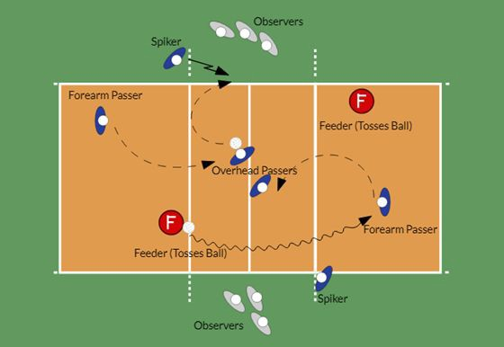
❖ Option 2: Performer and observer switch roles after the performance of each skill (e.g. Partner A performs 5 forearm passes then Partner B performs 5 forearm passes, etc.)

★ Could have Feeder be Serving and another observer watching him/her
○ Could impact passing of forearm passer (so may wish to avoid for less skilled players)

Possible Serving Assessment Set Up

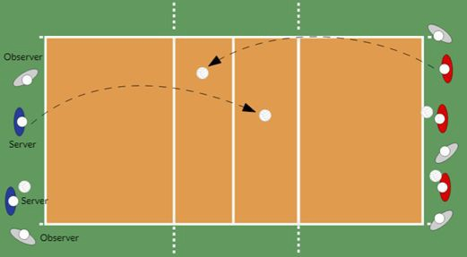
This is a potential set up where partners can observe student performance of the serve: Observers assess on five performances by their partner. Can switch after each serve to reflect on previous performance or do five trials in a row and then switch roles.

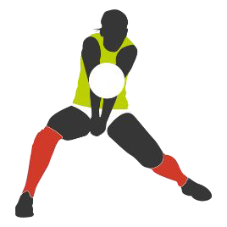
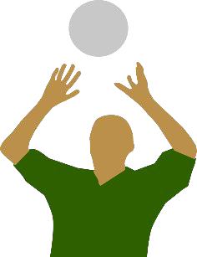
Skills |  | Attempts
FOREARM PASS |  | 1 | 2 | 3 | 4 | 5 | Comments
1 | Moved under the ball → Under the Ball
2 | Controlled arm movement to move platform to the ball → Reach out
3 | Platform contacts the ball at an angle to send the ball UP → Meet the ball
4 | Contacts forearm above wrists  → Hit the watch
5 | Pass was playable by the intended target
OVERHEAD PASS |  | 1 | 2 | 3 | 4 | 5 | Comments
1 | Moved under the ball → Under the Ball
2 | Hands over forehead → Binoculars
3 | Catch ball with finger pads → Quick Catch
4 | Extend up so hands point above target  → High Ten
5 | Pass was playable by the intended target
SPIKE |  | 1 | 2 | 3 | 4 | 5 | Comments
1 | Both arms are swung well back → BATMAN
2 | Step-Close as swing up → SUPERMAN
3 | Pull hitting arm back & point other arm at ball → GREEN ARROW
4 | High Five the Ball
5 | Ball hit over the net / landed “in”
Performer: Reflect on your performance and create a practice plan to advance your skills.
Example: I’ll begin each class rallying with a partner while focusing on using my legs for power rather than swinging my arms with my forearm pass.

Skills |  | Attempts
FOREARM PASS |  | 1 | 2 | 3 | 4 | 5 | Comments
1 | Moved under the ball → Under the Ball
2 | Controlled arm movement to move platform to the ball → Reach out
3 | Platform contacts the ball at an angle to send the ball UP → Meet the ball
4 | Contacts forearm above wrists  → Hit the watch
5 | Pass was playable by the intended target
OVERHEAD PASS |  | 1 | 2 | 3 | 4 | 5 | Comments
1 | Moved under the ball → Under the Ball
2 | Hands over forehead → Binoculars
3 | Catch ball with finger pads → Quick Catch
4 | Extend up so hands point above target  → High Ten
5 | Pass was playable by the intended target
SPIKE |  | 1 | 2 | 3 | 4 | 5 | Comments
1 | Both arms are swung well back → BATMAN
2 | Step-Close as swing up → SUPERMAN
3 | Pull hitting arm back & point other arm at ball → GREEN ARROW
4 | High Five the Ball
5 | Ball hit over the net / landed “in”
Performer: Reflect on your previous practice plan and your current performance. Did you improve? How do you feel about your overall performance? What are you most proud of? What would you still like to work on?

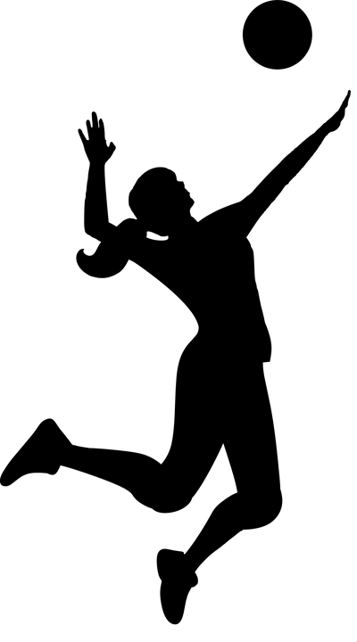
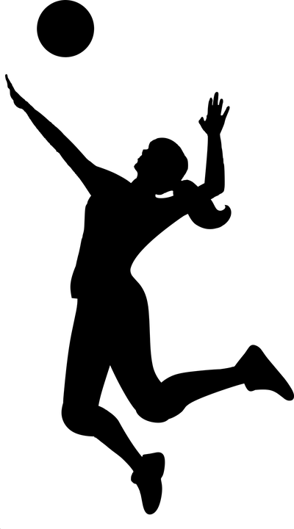

Evaluator: For each trial of the skill being observed check off when the performer does that particular aspect of the skill. Write any comments that might guide the performer in how to improve their performance.
Skills |  | Attempt
UNDERHAND SERVE |  | 1 | 2 | 3 | 4 | 5 | Comments
1 | Ball held LOW out in front of body
2 | Step & Swing → BOWL
3 | Releaser ball & hit with heel of hand →  DROP – HIT (waist high)
4 | FOLLOW THROUGH to Target
5 | Ball lands in bounds on other side of net
Performer: Reflect on your performance and create a practice plan to advance your skills.
Example: I will begin each class by practicing my serve by focusing on following through pointing to my target.

Performer: Evaluator:
Evaluator: For each trial of the skill being observed check off when the performer does that particular aspect of the skill. Write any comments that might guide the performer in how to improve their performance.
Skills |  | Attempt
UNDERHAND SERVE |  | 1 | 2 | 3 | 4 | 5 | Comments
1 | Ball held LOW out in front of body
2 | Step & Swing → BOWL
3 | Releaser ball & hit with heel of hand →  DROP – HIT (waist high)
4 | FOLLOW THROUGH to Target
5 | Ball lands in bounds on other side of net
Performer: Reflect on your previous practice plan and your current performance. Did you improve? How do you feel about your overall performance? What are you most proud of? What would you still like to work on?

Evaluator: For each trial of the skill being observed check off when the performer does that particular aspect of the skill. Write any comments that might guide the performer in how to improve their performance.
Skills |  | Attempt
OVERHAND SERVE (Gr 7/8) |  | 1 | 2 | 3 | 4 | 5 | Comments
1 | Bow & Arrow - Ball in off hand
2 | Tennis Toss the ball up & in front of self
3 | Step & Swing at the ball
4 | High Five the Ball
5 | Ball lands in bounds on other side of net
Performer: Reflect on your performance and create a practice plan to advance your skills.
Example: I will begin each class by practicing my serve by focusing on following through pointing to my target.

Performer: Evaluator:
Evaluator: For each trial of the skill being observed check off when the performer does that particular aspect of the skill. Write any comments that might guide the performer in how to improve their performance.
Skills |  | Attempt
OVERHAND SERVE (Gr 7/8) |  | 1 | 2 | 3 | 4 | 5 | Comments
1 | Bow & Arrow - Ball in off hand
2 | Tennis Toss the ball up & in front of self
3 | Step & Swing at the ball
4 | High Five the Ball
5 | Ball lands in bounds on other side of net
Performer: Reflect on your previous practice plan and your current performance. Did you improve? How do you feel about your overall performance? What are you most proud of? What would you still like to work on?

Volleyball Game Play Rubric (Gr 6/7)
Teacher: Div.: Date:
General | Cover (Defence) | Play Making (Offence)
- Demonstrates good sportsmanship & fair play (follows rules, etc.) at all times  - Tries to make a play on any ball near them (move to ball). | Adjusts position to cover any open space (i.e. NOT too close to teammates, net, or sidelines) so they can help make the next play on the ball [defense or offense] | - Tries to make a high pass to the center of their own team’s court so teammates can get the ball.  - Knows when it is the third hit and tries to put the ball over to the opponent's side

Performance Scale:
4 – Always demonstrated these concepts (~4+ out of 5 plays observed)
3 – Often demonstrated these concepts (~3 out of 5 plays observed)
2 – Sometimes demonstrated these concepts (~2 out of 5 plays observed)
1 – Rarely/Never demonstrated these concepts (~ 0/1 time out of 5 plays observed)

Name | G | C | PM | Comments

Volleyball Game Play Rubric (Gr 7/8)
Teacher: Div.: Date:
General | Cover (Defence) | Play Making (Offence)
- Demonstrates good sportsmanship & fair play (follows rules, etc.) at all times  - Tries to make a play on any ball  near them (move to ball). | Adjusts position to cover any open space (i.e. NOT too close to teammates, net, or sidelines) so they can help make the next play  on the ball [defense or offense] | Tries to put ball to the correct spot(s):  - 1st → To the Net  - 2nd → Along the Net  - Attack → To Open Space/Corners
Performance Scale:
4 – Always demonstrated these concepts (~4+ out of 5 plays observed) 3 – Often demonstrated these concepts (~3 out of 5 plays observed)
2 – Sometimes demonstrated these concepts (~2 out of 5 plays observed)
1 – Rarely/Never demonstrated these concepts (~ 0/1 time out of 5 plays observed)

Name | G | C | PM | Comments

Sample Volleyball Quiz Questions

- Games are to points, but a team must win by _____ points.

- Give an example score that fits the win by two points rule: to _____

- Points are awarded to a team on every serve. This is called?

- How many players are on the court for one team, at one time?

- What is the maximum number of contacts a team is allowed on their side of the net?

- What is special about a block?

- List three ways your team could win a point during a rally (i.e. after a successful serve).

- What are two of the three things a U13 player is NOT allowed to do when receiving the serve?

- What are three ways you can lose a point on your serve?

- Why is it called the attack line?

- Identify the 3 main skills cues used in class for the forearm pass.

- Identify the 3 main skills cues used in class for the overhead pass.

- Identify the 3 of the main skills cues used in class for the spike.

- Identify the 3 of the main skills cues, or analogies, used in class, for the underhand serve.

- Identify the 3 of the main skills cues used in class for the overhand serve.

- What are two things you want to focus on when positioning yourself on defence?

- Where do you want to hit the ball when attacking?

- Why you want your passes to go "To the Net" and then "Along the Net?"

Answer whether the following is true or false:

- You can hit the ball with any part of your body

- You immediately lose the point when the ball hits the net

- In a regulation match, a player can play the ball twice in a row (not including a block)

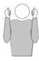
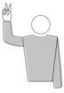
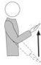
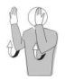
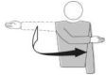
Match the hand signal with the call (Put the correct term under the picture):

- Carry
- Serve
- Out
- Double Contact
- Re-serve

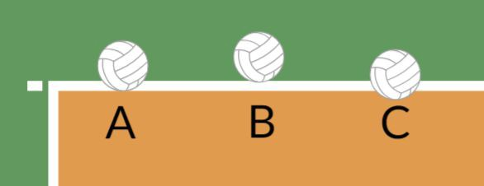
Circle which ball(s) landed “in” the court:

- Label the court positions and name the lines of the court on the following diagram:
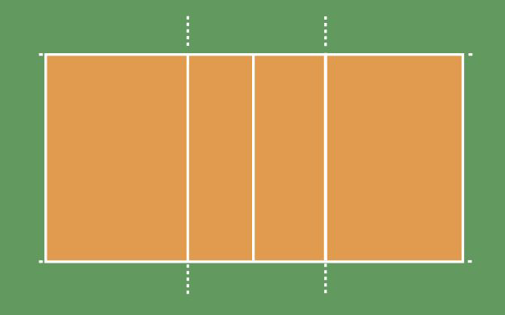
- Draw one team in defensive positions as they are about to serve and the other team in serve receive on the diagram below (Label which team is which):
Sample Volleyball Quiz Questions - Answers

1) Games are to points, but a team must win by points. |  | 25, 2
- Give an example score that fits the win by two points rule: to  - Points are awarded to a team on every serve. This is called?  - How many players are on the court for one team, at one time? |  | 24:26, 25:27, etc.  Rally Point  6
- What is the maximum number of contacts a team is allowed on their side of the net? 3

- What is special about a block?
It does not count as a contact for both the team and player → a person can touch the ball on a block and if it is close to them they can pass the ball right after!

- List Four ways your team could win a point during a rally (i.e. after a successful serve).
Opponent hits the ball out
Opponent hits the ball 4 times Opponent hits the net Opponent steps onto your court
Ball hits the ground on your opponent's side

- What are two of the three things a U13 player is NOT allowed to do when receiving the serve? Block the serve
Spike the serve
Pass the serve with your fingers (overhead pass)

- What are three ways you can lose a point on your serve? Step over the line (foot fault)
Serve doesn't go over the net Serve hits the antenna or ceiling Serve goes out of bounds
Toss the ball in the air and then, not hit it or catch it

- Why is it called the attack line?
The players in the back row (positions 1, 6, & 5) may not "attack" [i.e. Jump higher than the net] from in front of that Line.

- Identify 3 main skills cues used in class for the forearm pass.
Under the Ball, Reach Out to Meet the Ball, Hit the Watch

- Identify 3 main skills cues used in class for the overhead pass.
Under the Ball, Binoculars, Quick Catch, High Ten

- Identify 3 main skills cues used in class for the spike.
Batman, Superman, Green Arrow, High Five

- Identify 3 main skills cues used in class for the underhand serve.
Low, Bowling, Drop & Hit, Follow Through

- Identify 3 main skills cues used in class for the overhand serve.
Bow & Arrow, Tennis Toss, Step & Swing, High Five

- What are two things you want to focus on when positioning yourself on defence?
Spacing yourself from your teammates to cover as much of the court as possible; be opposite attacker / cover angles

- Where do you want to hit the ball when attacking?
To Space (Variations: To Corners, Deep/Short & Sides of Court, On Angles, Away from Opponents)

- Why do you want your passes to go “To the Net” and then “Along the Net?”
“To the Net” gets the ball closer to the other side – easier to hit over the net!
“Along the Net” hides who will be attacking the ball (Similar to Soccer Corner Kick); Keeps attack close to the net

Answer whether the following is true or false:

- T You can hit the ball with any part of your body.

- F You immediately lose the point when the ball hits the net.

- F In a regulation match a player can play the ball twice in a row (not including a block)

Re-serve Double Contact Carry Out Serve

- Circle which ball(s) landed “in” the court:
They are all in! B is “just” touching the line so it is still considered “in”

- Label the court positions and name the lines of the court on the following diagram:

Endline (Baseline)
2
1
3
6
4
5

Attack (3 meter) Line

Centerline

- Draw one team in defensive positions as they are about to serve and the other team in serve receive on the diagram below (Label which team is which):

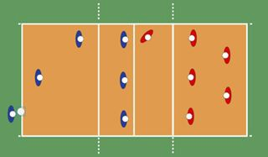
Serving Team Serve Receive

