Viking Raid
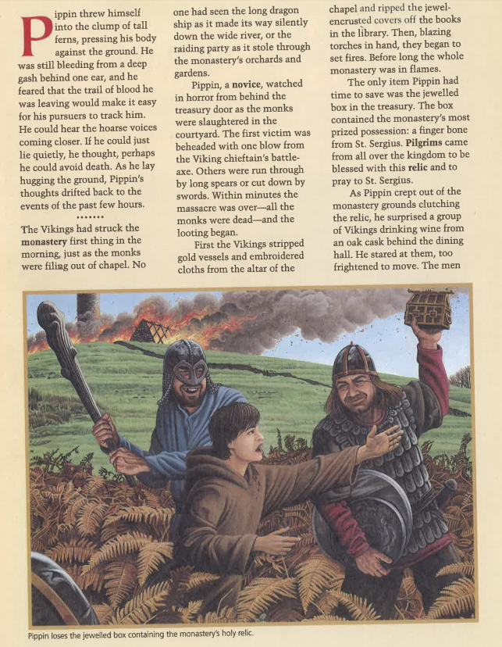
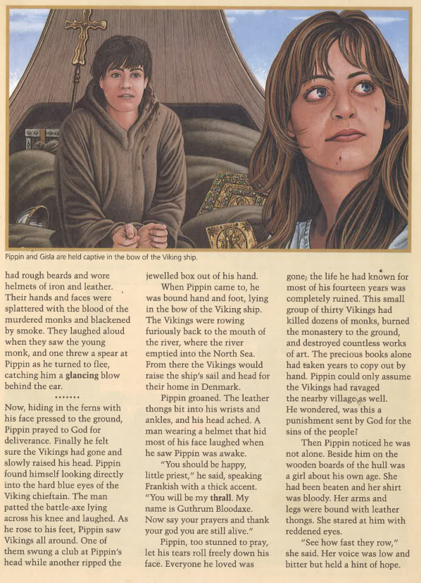
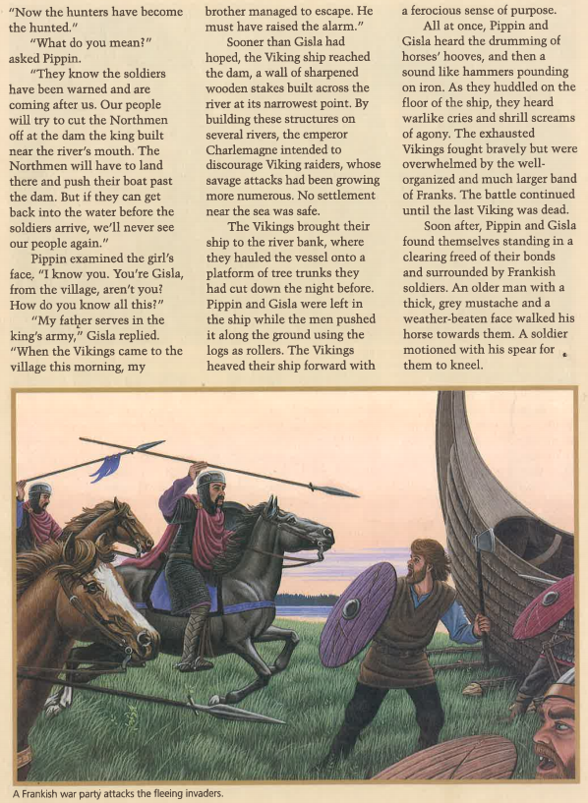
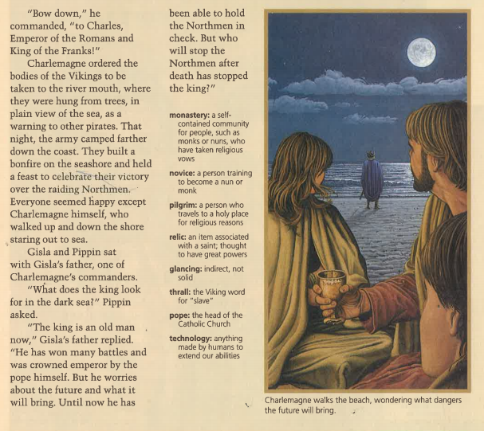
Viking Raid Questions
Please answer on a separate lined sheet of paper/ Google doc
- What sort of loot did the Vikings want?
- What did Pippin try to save? Why?
- Based on the story describe the Vikings, their raids, and their ships.
- What did Charlemagne do to try to discourage Viking raids?
- Based on the story, what was the Viking strategy of attack?
- Research how Alfred the Great of England tried to stop the Viking raids.
- Based on the strategies of Alfred the Great and those mentioned in the story, how would you have tried to stop the Vikings?

