The Viking Age: 783-1066
Name: Div: Date:

Use your Viking information booklet, and the information on the last page to answer the following questions:
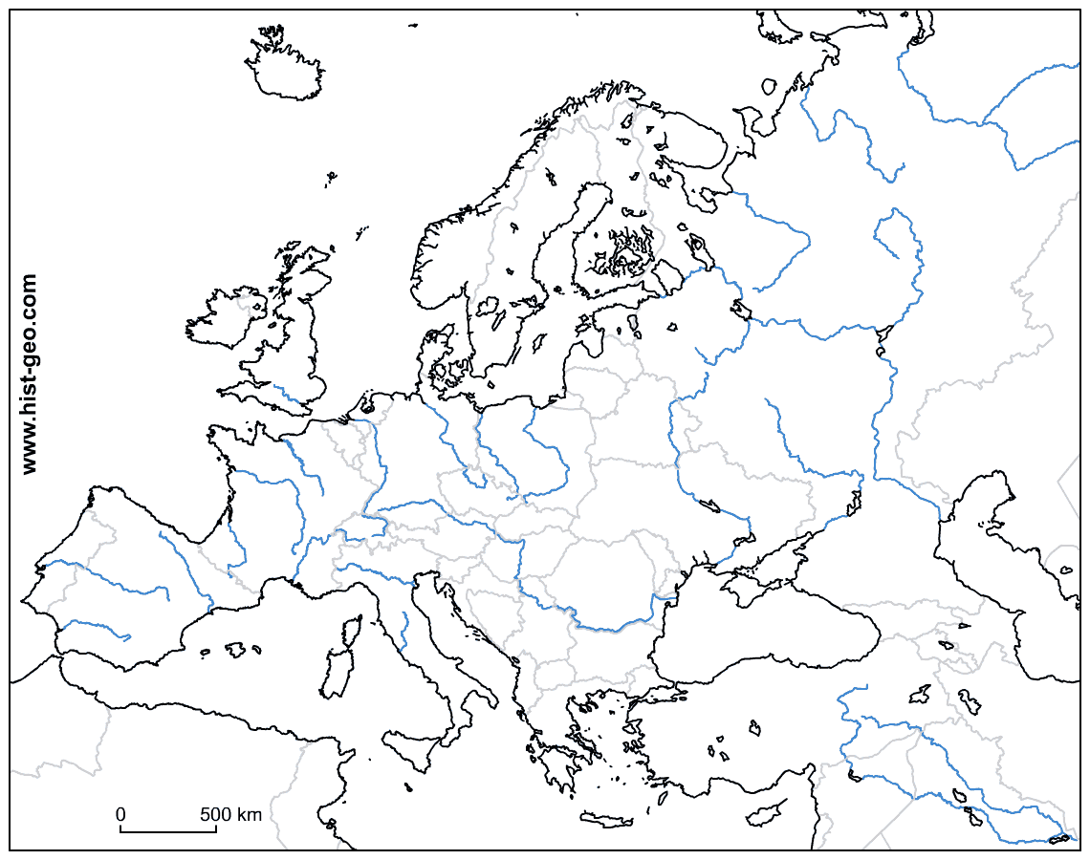
- Fill in the exploration routes of the Vikings on the map above and explain how the Vikings were able to travel so far inland.

- What made the Vikings ships ideal for raids?

- Read the description in “Of Lightning and Dragons.”
  - What is a “portent?”

  - How is the Chronicle describing the attack? Why do you think they are describing it this way?

  - Why did people think the Vikings were raiding? How does this add to your understanding of the description in “Of Lightning and Dragons?”

- Describe the early common practice of Viking raiders. How would this practice have helped later Viking raids?

- What did some leaders like “Ethelred the Unready” do to get the Vikings to leave their lands? What leaders were able to fight the Vikings effectively?

- Why did the Vikings go on their raids?

- Using specific examples, explain how women were treated differently in Viking society compared to the Franks.

- Use the translations on pg. 34 to write your name in Runes:

:
Your Name

- Compare Viking law with Frankish law, which do you think is more severe? Fair?

- Explain, based on all that you have read, if you think description of the Vikings in “Of Lightning and Dragons” is fair, and why or why not?

- Explain the convergence of events that caused “The Viking Age” come to an end, and how they ended Viking raids.

- What contributions did the Vikings make to our modern society?
Norse Mythology = Days of the Week:
Tuesday - Tyr’s Day (Son of Odin)
Wednesday – Odin’s (Wotan) Day
Thursday – Thor’s Day
Friday – Freya’s Day

The Vikings
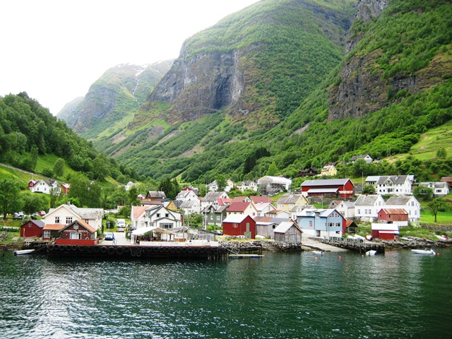
If you look at the map you will see that these Vikings lived in the present day countries of Denmark, Norway and Sweden. Because they lived in the north of Europe they are sometimes called the Northmen or Norsemen. Much of the coastline of the lands of the ‘Northmen’ is broken up into inlets of the sea know as fjords. Between these fjords are high mountains which make it easier to go from one inlet to another by sea rather than by land. So the Vikings soon became skilled seaman. It was not easy to make a living by farming. The land was rocky and covered with forests, and so the Vikings preferred to go on raiding voyages. It was the custom of the Vikings that when a man died the whole of his possessions went to his eldest son. Younger sons had to make their own way in the world. So they went on voyages of exploration and plunder. The adventurous ones would tell stories of fertile lands across the sea and show jewelled ornaments plundered from Christian churches in places such as England and France. No doubt these would make more Norsemen eager to set out on raids. Some Vikings even had their wealth buried with them and so their sons also had to take to the sea life of plunder.
Viking Ships
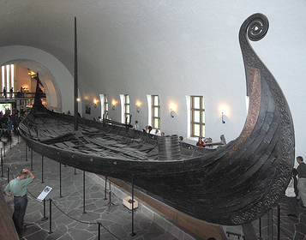
The ships built by the Vikings were much better that the Keels used by the Angles and Saxons when they came to England. The Viking Longboat or Dragon Boat was nearly 24 meters in length and about 5 meters in width. It was deeper than the Saxon Keel and it had a great square sail that was often painted in stripes of red, blue, or green. The longboat was pointed at both ends. This made it easier to use in narrow fjords or in rivers, as the ship could be moved forwards or backwards without having to turn around. The mast could be taken down in calm weather and the ship was then driven by the oarsmen. When the oars were not being used, the crew was able to hang their shields over the sides. A great wooden paddle was fixed to the right hand side of the vessel. This was the steering board side from which we get our word Starboard. The bow had a ferocious dragon’s head carved on it to scare enemies.
Viking Voyages
Viking went on many long voyages of exploration. Some explorers started settlements in the land we today call Iceland. One of these, Eric the Red, had such a terrible temper that he had to flee from his home there and sail into the unknown seas to the west. There he discovered a land he named Greenland. Eric the Red’s son, Leif Ericson or Leif the Lucky sailed from Greenland and discovered a land which he called Vineland because of the wild vines that he found. He also discovered to more lands, one he called Helluland, the other Markland. While other Vikings explored made contact with Chinese and Muslim traders in the east.

