Using Linear Equations
Name: Div.: Date:

b) Create a Table of Values c)
d) What would it cost to talk for 45min? 1hr?

e) Which method did you use to find the answers to the above question? Why did you choose that method? How else could you have found the answer?

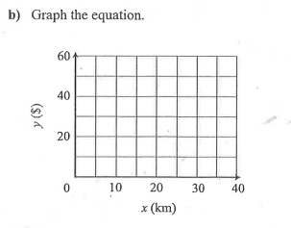
c) How much (roughly) would it cost to go 30km?

d) How far could you go (roughly) with $60?

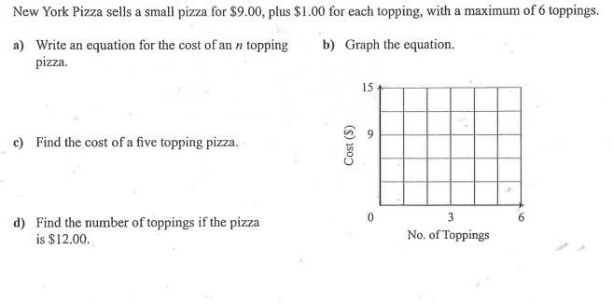
e) How much would a 6 topping pizza cost?

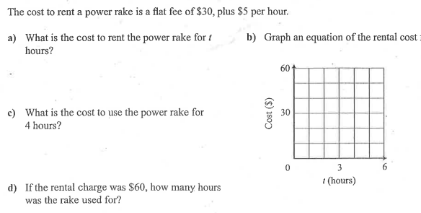

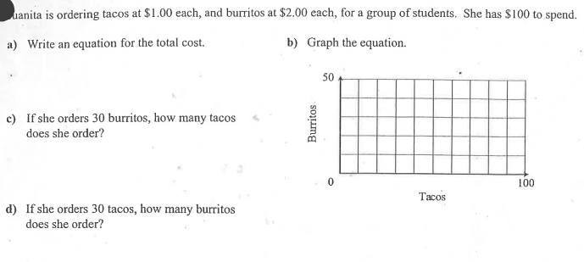
Maria

