**The Manor System & Self Sufficient Sustainability**

Name: Div.: Date:

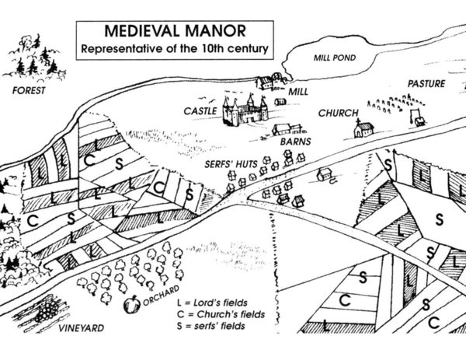

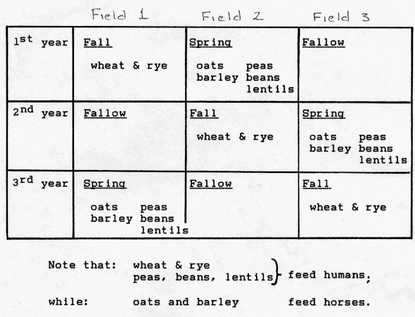

In the autumn one third was planted to wheat, barley, or rye, and in the spring another third of the land was planted to oats, barley, and legumes to be harvested in late summer. The legumes (peas and beans) strengthened the soil by their nitrogen-fixing ability.

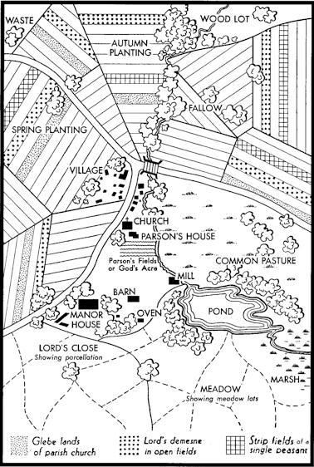

**Tasks:**

1. Create your own diagram of a manor with labels for:
   1. Woodland (woodlot), River, Meadow, Orchard, Road, Tannery, Church, Mill, Oven (Bakehouse), Cottages/ Serf’s Huts, Manor House/ Castle, Common Pasture, Fields (1,2,3)
      1. Show strips for serf’s, church, and lord
      2. Show which fields would planted/ fallow
2. Explain how each part of the manor was important to the Manor, and its self sufficiency
   1. E.G. The river was important as a source of water for cooking and cleaning, as well as gathering some fish to eat!
3. Create a diagram that explains how the three field system made the farming sustainable.