Subtracting Fractions
Name: Div.: Date:

Solve the following problems.
Put your answers into lowest terms, with mixed numbers (where possible):
 | 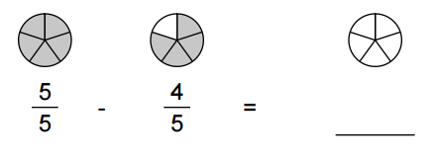
 | 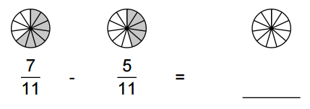
 | 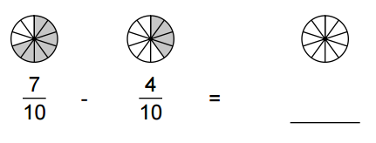
 | 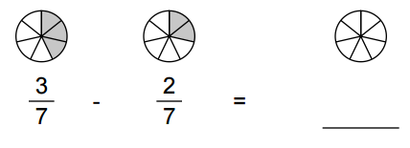
 | $$\frac{4}{5}-\frac{1}{5}-\frac{1}{5}=$$ |  | $$\frac{6}{8}-\frac{1}{8}-\frac{3}{8}=$$
 | $$\frac{2}{3}-\frac{1}{9}=$$ |  | $$\frac{2}{5}-\frac{1}{10}=$$
 | $$\frac{2}{3}-\frac{7}{12}=$$ |  | $$\frac{5}{7}-\frac{11}{21}=$$
 | $$\frac{4}{7}-\frac{2}{5}=$$ |  | $$\frac{3}{8}-\frac{1}{3}=$$
 | $$\frac{7}{10}-\frac{1}{3}=$$ |  | $$\frac{3}{4}-\frac{1}{5}=$$
 | $$\frac{8}{12}-\frac{3}{14}=$$ |  | $$\frac{3}{21}-\frac{5}{54}=$$
 | $$\frac{10}{18}-\frac{8}{21}=$$ |  | $$\frac{13}{21}-\frac{7}{28}=$$
 | $$2\frac{1}{3}-1\frac{1}{2}=$$ |  | $$3\frac{2}{3}-1\frac{1}{2}=$$
 | $$5-3\frac{5}{8}=$$ |  | $$3\frac{13}{18}-2\frac{6}{21}=$$
 | $$4\frac{2}{9}-2\frac{13}{18}=$$ |  | $$12\frac{5}{16}-9\frac{7}{12}=$$
 | Lorena poured $2\frac{2}{3}$ cups of milk in her measuring cup. But she only needed $1\frac{1}{3}$ cups of milk. She wants to pour the amount of milk she does not need back in the milk carton. How much should she pour back?
 | An estate was left to four children. The first child received $\frac{1}{4}$ of the estate, the second child received $\frac{1}{6}$ of the estate, the third child received $\frac{3}{8}$ of the estate. How much of the estate did the fourth child receive?
 | A business is owned by three people. The first person owns $\frac{5}{12}$ of the business, and the second person owns $\frac{1}{3}$ of the business. What portion of the business does the third person own?
 | Aaron works 20hours per week on a part-time job. He works $\frac{1}{4}$ hours on Monday, $\frac{1}{4}$ hours on Tuesday, and $\frac{1}{4}$hours on Wednesday. How many more hours does he work during the remainder of the week?

