Dining Out Math
Name: Div.: Date:

Conversely, if you take the total and divide by the amount you paid for a %, or the % you know, you get the total amount.
Amount
%
Base
If you take the percent and multiply by the base you get the amount you pay for that %.

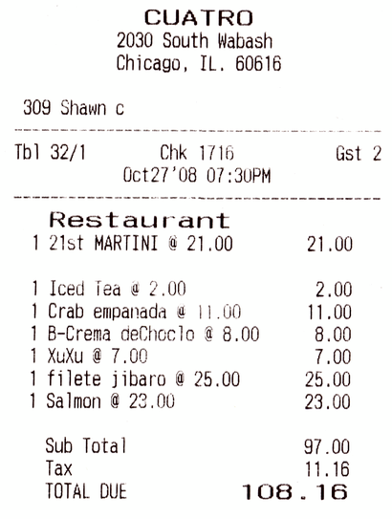
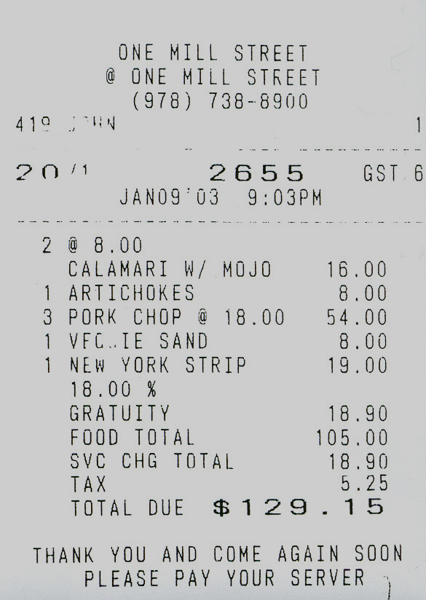
Figure A. Figure B.

Use Figure A to answer the following questions:
- Estimate the percent tax on the bill (Sub Total = Base)

- What percentage of the bill was food (Martini, Iced Tea, and XuXu are drinks)?

- What percentage of the bill were drinks (Martini, Iced Tea, and XuXu are drinks)?

*Generally you tip on the Sub Total*
- What should you tip on the bill, from Figure A, if you chose to tip:

 | Total Due ($108.16) | Sub Total ($97)
10%
15%
20%

- Based on your calculation in the above question, explain how you can quickly calculate 10, 15, and 20%.

Use Figure B to answer the following questions:
- Estimate the percent tax on the bill (Food Total = Base).

- What percent was the tip (Gratuity) added to the bill?
Some restaurants will automatically add a “Gratuity” to the bill for groups over a certain size.

*Generally you tip on the Sub Total*
- What could you have tipped on the bill if you chose to tip:

 | Sub Total | Total Due
10%
15%
20%

- There were 5 people at this dinner. Assume they shared the Calamari and Artichokes equally. Calculate how much each person needs to pay if they share the appetizers and tax cost, pay for their own main (Pork Chop, etc.), and include a 15% tip for their portion of the meal.

Person #1:

Person #2:

Person #3:

Person #4:

Person #5:

