The “BLACK DEATH”

A Great Plague killed nearly half of the people of Europe during in the fourteenth century. A plague is a widespread illness. The plague was also known as "the Black Death.” Even though it caused much devastation, the plague also ended up bringing about some more positive changes to Europe.

Spread
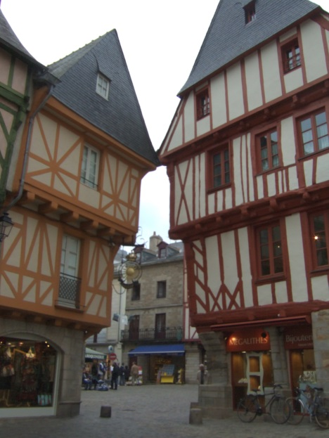
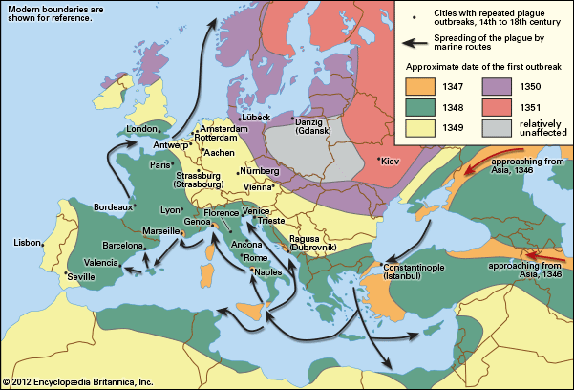
The sickness apparently began in Central Asia, and travelled along the Silk Road. Then, in 1347, the Golden Horde launched their own, plague infected, soldiers into the city of Kaffa. Italian merchants trading in Kaffa had ships that were dirty, and infested with rats. Infected fleas boarded the ships on the backs of rats, and later transferred the disease to the traders. Many of the sailors were already dying of the plague as the infected ships returned to Italy. Within days of an infected ship’s arrival, the disease spread quickly thanks to the conditions in cities.
The cities of Europe had begun developing around castles and were protected behind cities walls. However, they had been growing steadily larger since the time of the Crusades, as trade increased. As these towns grew they had little sanitation and even less space. To stay within city walls buildings were built up (as many as six stories) with each story sticking out a little more until the buildings across from each other would almost be touching. Each building was crowded with whole families living and sleeping in one room! Since there was no indoor plumbing people would throw their “waste” from their windows, onto the streets, shouting “Garde Lou” (heads up!). Heavy rains would wash away some of the filth; but mostly, pigs and other animals acted as the street cleaners eating the garbage and waste, at night. This filth was a perfect breeding ground for the rodents (rats, hamsters, etc) that would carry the rats that carried the plague.
As a result, within three years the plague had reached Spain, France, England and Russia. Although it is impossible to calculate exactly how many people died from the plague, evidence suggests that it claimed the lives of as many as 35-70 million Europeans (1/4-1/3 of the population).
Symptoms

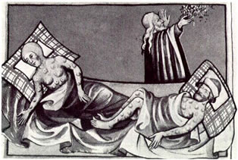
The first sign of the plague was often as flu-like symptoms (fever, aches and pains, etc.), and then the lymph nodes would swell to the size of an egg, or apple. The lymph nodes are glands found in the neck, armpits, and groin. The swelling, in the lymph nodes, would continue for three or four days and then possibly burst oozing black liquid. The sufferer would also possibly vomit blood, develop gangrene and black spots all over their body (as the bacteria decomposed the person’s skin from within) have seizures, and if they were lucky – fall into a coma. The illness is often called the Bubonic Plague. “Buboes” is a Greek word that refers to swollen glands.

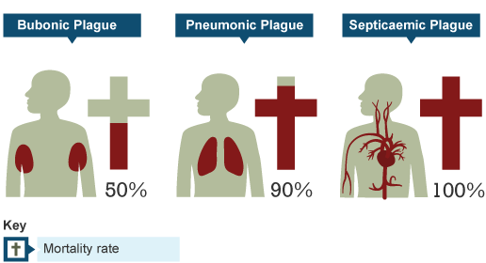
Occasionally the infection would enter the lungs and turn into Pneumonic Plague, which could be transferred through their bloody coughs. Worse still, the infection could enter the blood and become Septicaemic Plague where the victim would bleed from their orifices and develop gangrene on their extremities (blackened fingers and toes).
The swiftness of the disease (Die within 3-7days of signs of infection), the enormous pain, and the grotesque appearance of its victims served to make the plague especially terrifying. Death from the plague was horrible, but swift.

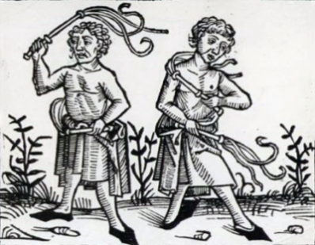
Beliefs
Some Europeans believed the plague was punishment from God. Groups known as Flagellants tried to atone for the sins of the world by inflicting punishments upon themselves.
Others believed it was the end of the world and began to live a hedonistic lifestyle (eat and drink whatever). Others who thought that thinking about the plague would cause it lived similarly.
Some believed that foreigners, or Jewish people, had poisoned their wells, making them sick. This stemmed from Jewish people being segregated from the others and having better personal hygiene due to their religion (didn’t get sick as much). As a result of this, numerous Jewish populations (510) were massacred, culminating in the Valentine’s Day Massacre, in Strasbourg. In Strasbourg, 900 Jewish people were burned alive before the plague had even reached the city.
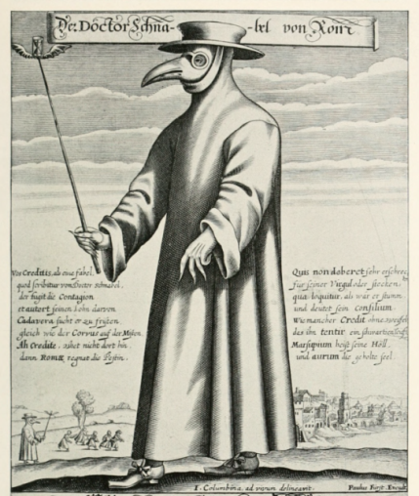
Many thought that miasma (bad odors/air) caused the disease. So, many carried sweet smelling flowers in their pockets (posies). Others fled to the countryside to avoid the bad smells of the city.

Plague doctors wore a long mask filled with sweet smelling flowers/odors to avoid the miasma and thick leather coats, and goggles, to prevent getting splattered from pneumonic plague. They also carried sticks to direct family members on what to minimize contact.

Treatment?
Bleeding, sweating, vomiting | These cures were linked to the idea that the disease was caused by the four body humours (fluids) becoming unbalanced. To bleed a patient the veins leading to the heart should be cut open, and as they bleed, the disease should leave the body, through the fluid. An ointment of clay and violets should then be applied to the place where the cuts were made. Sweating and vomiting should also allow the plague to leave the body through the fluid.
Dried toads  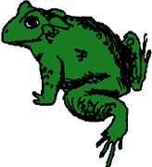 | A popular suggestion among doctors was to put a dried toad onto the victim’s plague boils. A doctor at the time wrote instructions:  “Toads should be thoroughly dried in the air or sun. They should be laid on the boil. Then the toad will swell and drain the poison of the plague through the skin to its own body. Once the toad is full, it should be thrown away and a new toad applied to the boils.”
Figs and Cooked onions | Figs and onions could be used as a cure. A medieval sufferer wrote about this treatment: "The swelling should be softened with figs and cooked onions mixed with yeast and butter. When they are open they should be treated with the cure for ulcers. I developed a fever with a swelling in the groin. I was ill near on six weeks. When the swelling had ripened and had been treated in the way I prescribed, I escaped, by God's Grace".
Lancing the buboes | This involved the buboes being cut open to allow the disease to leave the body and then the wound would be lanced with a hot metal poker.
Prayer | Prayer – priests would pray for people to get better by reciting an old version of the phrase “father, son, and holy spirit” – “Abra Ca Dabra”. They would also wear charms with the words, or place a charm on the door in an attempt to stop the disease.
Don’t Wash | Some thought washing would open the pores to the disease. The filth only kept other people away and made things worse.
Quarantine | In Milan, whole families would be bricked up in their houses, and left to die. Many cities refused to allow outsiders to enter their city.
Give Up | Most cities had men called “gavoti” who, for a large fee, would carry the dead to be buried. They sometimes even took people who were sick, to be buried alive, since they were sure to die anyways. Unfortunately, by coming in close contact with the infected and travelling to numerous towns to make money the “gavoti” helped spread the plague.
Results of the Plague

The Great Plague transformed Europe. Ironically, because people thought bad smells were the cause of the disease many cities were cleaned up: “You are to make sure that all the human excrement and other filth lying in the street of the city is removed. You are to cause the city to be cleaned from all bad smells so that no more people will die from such smells.”- A letter from King Edward II to the Lord Mayor of London (1349).

Conversely, entire villages were sickened, forcing the few remaining survivors to move to cities to find work. These labour shortages on manors, caused by the death toll, led to a demand for increased wages by the remaining peasants. This resulted in laws against increased wages, which angered many peasants. In some cases, feudal lands were often converted to raising sheep and other animals, because grazing required less labor than farming. This change in labour effectively ended feudalism; it requires lots of cheap labour of which there was neither, after the plague.

Lastly, the ineffectiveness of the church in combating the plague, and the fact that the wealthy could run away from the disease led to a lot of resentment towards the church and upper classes. This resulted in a weakening of the churches power, and an end to feudalism. No longer were people willing to accept their lot in life, they could get a better life away from their lords, make their own fortunes, and were willing to fight for their rights.

The Plague Continues

The Great Plague continued to affect cities from time to time for hundreds of years. It still exists and is common among rodents. We have a cure for the disease (antibiotics), but occasionally people in isolated places still die from Bubonic Plague.

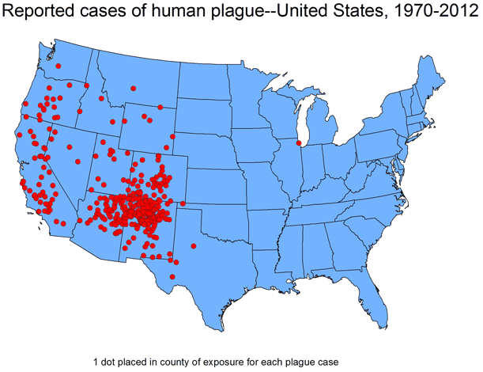

PLAGUE

Name: _________________________ Div.: Date: ________________________

Using the information in your plague booklet, and pg 164-165 in you supplemental booklet, answer the following questions:

- Where did the plague start? How did the plague spread to Europe?

- What who/ what carried the plague to other cities?

- Describe what medieval cities were like, and how these conditions helped spread the plague.

- Why was it called Bubonic plague? Black Death?

- What were the three types of plague? How were they different?

- Based on Boccaccio’s description on pg. 164 in the supplemental booklet what feeling do you get about the plague? Why? (Hopeless? Positive?)

- How is the Italian writer Boccaccio description of plague victims as having “ate lunch with their friends, and ate dinner with their ancestors in paradise” an accurate description of plague victims?

- Complete the following table:

Belief about the Plague/Health | Result  (Treatment/Actions people took, etc.)

- Based on pg. 165, in the supplemental booklet, explain how the plague affected the manor (# of serfs ==> payment to serfs ==> profit/loss?).

- How did the plague change cities?

- How did the plague help end Feudalism?

- How did the plague weaken the power of the church?

- What are some modern hold overs from the plague? (Words we/England use? Nursery Rhymes?)

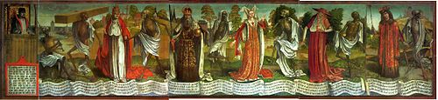
Bernt Notke: Surmatants (Totentanz) in St. Nicholas' Church, Tallinn.

The image above is from Totentanz textbook (Anon.: Vierzeiliger oberdeutscher Totentanz, Heidelberger Blockbuch, approx. 1460), shows death coming for each person. The dance finishes (or sometimes starts) with a summary:
"Who was the fool, who the wise [man],
who the beggar or the Emperor?
Whether rich or poor, [all are] equal in death

- How does the dance, and image, from above, summarize the plague?

- The above image/dance was a common theme through the 1400s. How does this demonstrate the impact of the plague on the psyche of the people?

(Adapted from Mrdowling.org)

