Badminton Notes
Name:

Singles:
Service Court
NET
Game Court

Doubles:

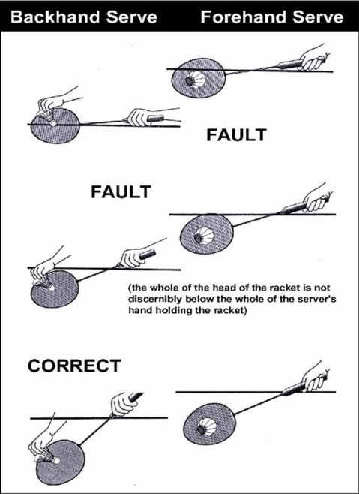
Basic Rules:
- Games are to 21pts (Win by 2 pts; capped at 30; i.e. 29-29 = next point wins)
- Serving:
  - Serving starts from the right hand court
    - Server serves into the receiving court diagonal from him/herself
  - The birdie must be below the servers waist, when struck
  - The WHOLE head of the racket must be below the wrist
  - Once your racquet is moving forward you have attempted to serve!
    - No re-do’s if you miss the birdie!
  - Serve is rally point and alternates between teams and teammates.
    - E.G. If you lose serve your opponent serves next and then your teammate and then your opponent’s teammate, etc. as each person loses their serve.
- You cannot touch the net with any part of your body, or racquet
- You must return the birdie to your opponent in 1 hit (same in both singles and doubles!)
Skills:
- Forehand

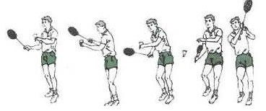

- Serve

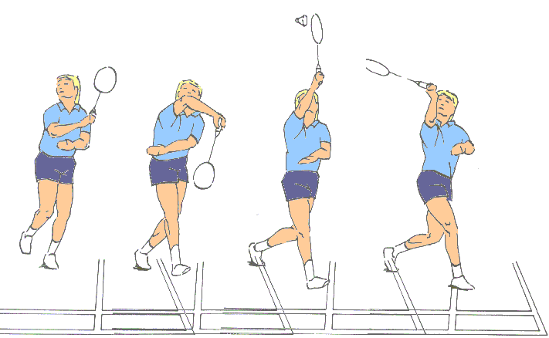
- Backhand

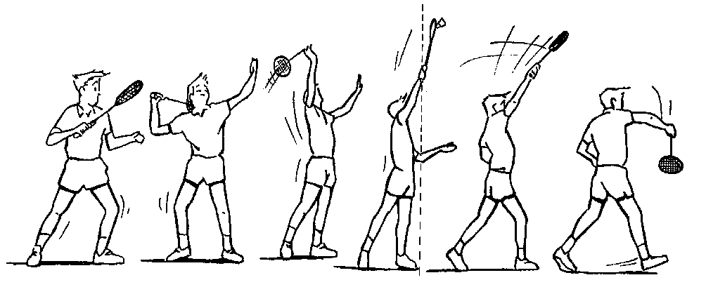
- Overhead smash

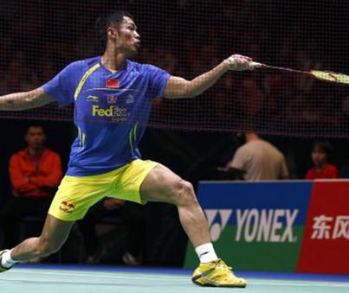
- Drop Shot

