Life in Medieval Towns
Name: Div.: Date:
Using the information from pg 149-155 in your supplemental answer the following questions.
- Explain how the Crusades, and increased trade resulted in the creation of towns?

- Fill in the following chart on the potential pros and cons of guilds:
Pros | Cons

- Complete the following table with the information about what happened at each level and how one moved up to the next level of “Becoming a Master of a Craft.”
Apprentice
(2-7years)
Journeyman
(3-5 years)
Master

- List 4 of the rules for seamstresses from “The Written Rule” primary source:

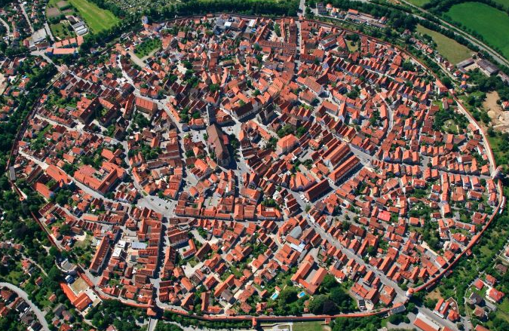
- Describe a medieval town.

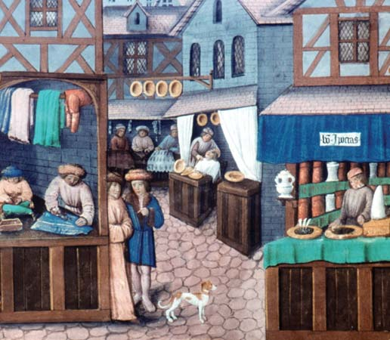
- What activities did they have to entertain people, in medieval towns?

- Explain how trade helped end feudalism.

Bear & Bull Baiting (Bulldogs were bred for Bull fights!)

