How Light Interacts with Matter

NAME: Div.: Date:

The ray model is a basic example of how light moves showing it in a straight line. This simplistic model is still useful because it can accurately demonstrate how light will react when interacting with matter.

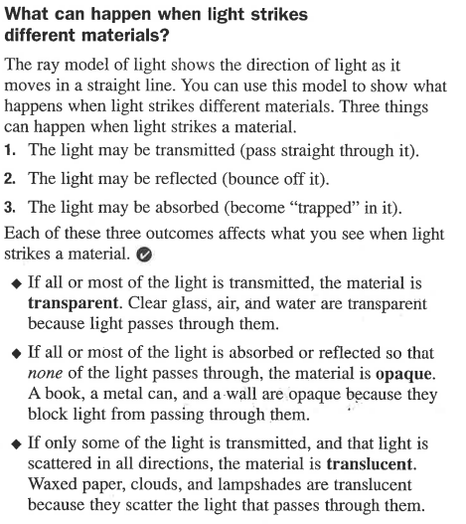

TRANSMISSION
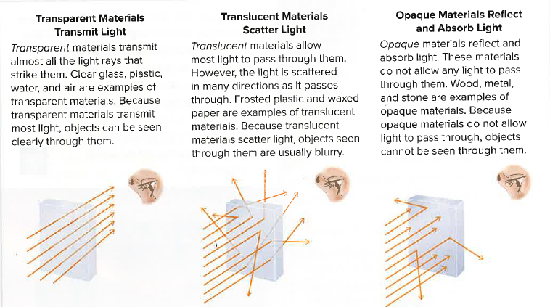

REFLECTION

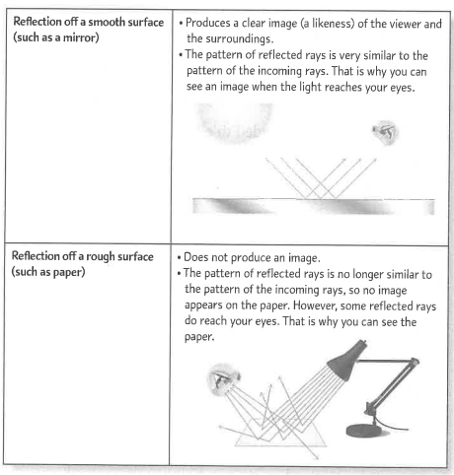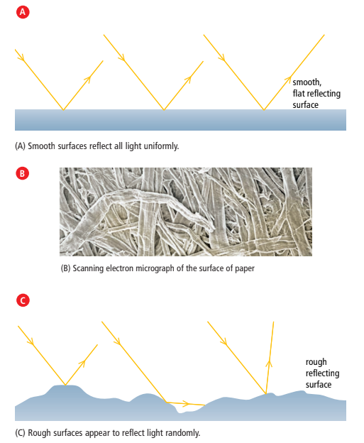

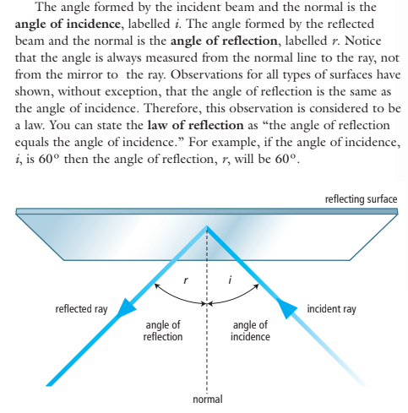
REFRACTION

Refractive index of some transparent substances
Substance | Refractive index | Angle of refraction if incident ray enters substance at 20º
Air | 1.00 | 20
Water | 1.33 | ~ 15
Glass | 1.5 | ~ 13

- All angles are measured from an imaginary line drawn at 90° to the surface of the two substances This line is drawn as a dotted line and is called the normal.
- If light enters any substance with a higher refractive index (such as from air into glass) it slows down. The light bends towards the normal line. (Travelling Air to Glass: 20 ÷ 1.5 = ~13)
- If light traveling enters into a substance with a lower refractive index (such as from water into air) it speeds up. The light bends away from the normal line. (Travelling Water to Air: 15 x 1.33 = ~20)
- A higher refractive index shows that light will slow down and change direction more as it enters the substance.
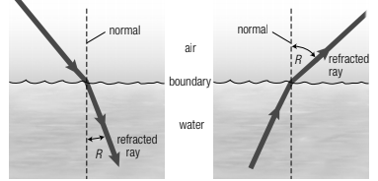

ABSORPTION

* Light energy can be absorbed and not reflected. When the different wavelengths of colours are absorbed the ones that are reflected are the colour that you observe the object to be. As light energy is absorbed heat is generated.

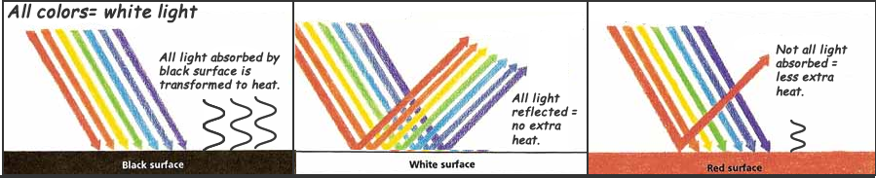

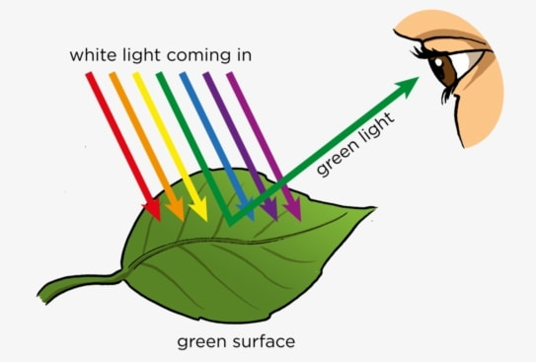

How Light interacts with Matter

Name: Div.: Date:

- Define the following terms:

  - Transmission
  - Reflection
  - Law of Reflection
  - Absorption
  - Transparent
  - Opaque
  - Translucent
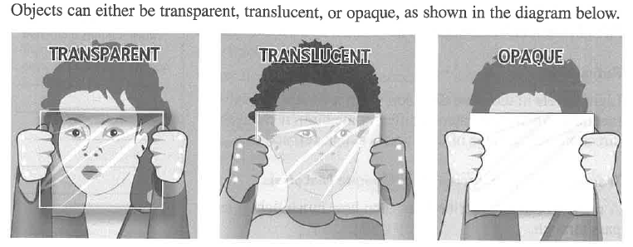

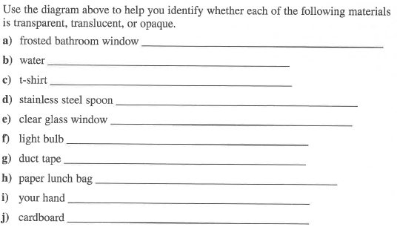

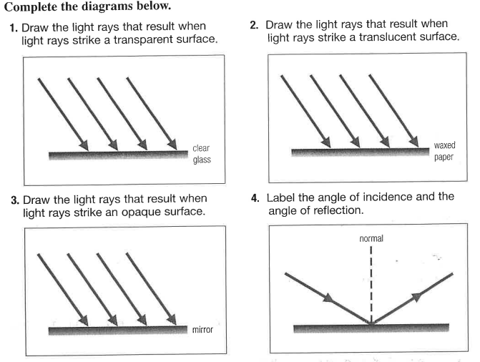
Define the following terms:
  - Refraction
  - Scattering
  - Absorption

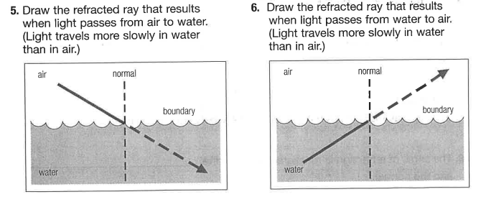
- State whether light is mostly absorbed, reflected, transmitted, or scattered by each object in the image below.
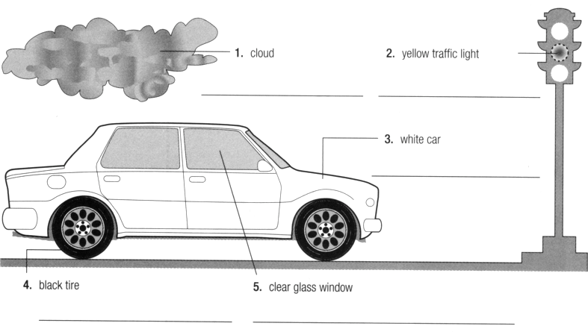

Research and Relate

- Why would the Polar ice caps melting and exposing more ocean water or land underneath make Global Warming worse.

- Could cities painting roofs or streets white help cool down the city?

- Why is the sky blue for most of the day, but red, orange, yellow at dawn and dusk?

