Heraldry:
Create Your Own Crest

Name: Div.: Date:

Using the “Heraldry meanings” package, and the shield cut out provided, you will be creating your own crest to represent yourself! Some of the original crests represented something that a person had done, or trait they had shown; defended well in battle, for example. However, some lost all meaning as the ages progress and were just decorative, while others still were puns based on the name of the person, or place (see the example below):

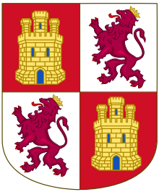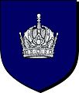
Crest of the Crowninsheild family
“Castle and Lions” representing the crest for the Kingdom of Castile & Leon

- Your crest you must include, at least two symbols, two colours, and 1 division (Unless otherwise discussed with Mr. Howe)

- In addition to creating your shield, you must also write a paragraph, using proper grammar and spelling, that clearly explains why you chose the colours, divisions and symbols of your crest.
  - The Symbols/colours/Divisions should relate back to you in these ways:
    - Your past (helped defend someone, had troubles, etc. – You don’t need to go into details)
    - How you think of yourself as a person now (trustworthy, etc.)
    - What you want for the future (Hope, Military, Peace)
    - Other details (places you’ve been, teams you played on “The Lions”, etc.)

Marking
If you feel you have a good reason to not follow the criteria (i.e. Onomatopoeic Name) talk to Mr. Howe.
Shield 5 marks
Paragraph 10 marks
Total 15 marks

