Feudalism Comes to England
Name: Div.: Date:

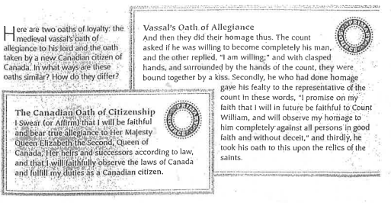
- Compare and Contrast the above Oaths (Feudal Vassal Oath and Canadian Oath of Citizenship)

Reading #1
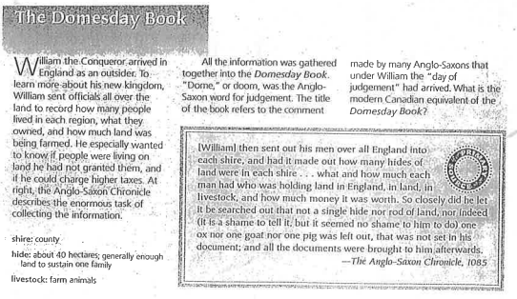
Reading #2
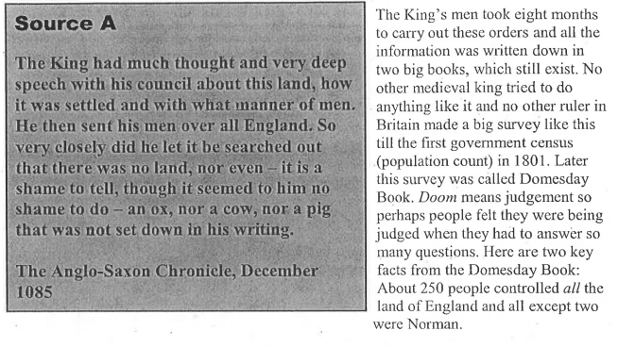
- From the above readings, how did the Anglo-Saxon Chronicle feel about the Domesday book? What phrases/ words give you that idea?

- Do you think people’s feelings about the Domesday book were fair? Why or why not?

- Why did William want the Doemsday Book? Why would it have been useful for him? Why would it be useful to historians today?

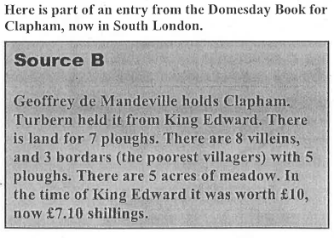
- From Source B, what evidence
is there that things got worse
in Clapham, after William
came to power?

- Come up with an initial hypothesis about why things got worse in Clapham?

