Name: ______________________ Div. ­­­_____ Date: _____________________

Read the reasons for the decline of Rome. After reading, rank each reason in order of important starting with 1 for the most important. When told, you will find 3 or 4 others and compare your rankings, and try to come to a consensus about the order of importance for these factors.

|  |  |  |
| --- | --- | --- |
| **Factors that influenced the decline of Rome** | **Your Ranking** | **Group’s Ranking** |
| (200s CE) The Germanic “Barbarians” of Northern Europe (e.g., Visigoths, Vandals) fleeing the Huns constantly invaded Roman territory. |  |  |
| The Senate reduced the funding to the army, and banned themselves and their workers from joining the army (protect their wealth). So, there were fewer troops and less money for the Roman Army. |  |  |
| Western Rome had 24 Emperors in 50yrs; each Emperor came to power by either assassinating the previous, or by winning a Civil War (Wanted to be Emperor to gain greater wealth). With no stable government Western Rome’s trade and general workings fell into chaos. |  |  |
| The Empire became too large and the borders were too long to defend. So, (282CE) Diocletian split the Empire into East and West increasing the size of their armies and bureaucracy. (Spending more $ = less money for the empire) |  |  |
| Constant warfare (civil and otherwise) led to reduced trade and production of food. Less money and food for the empire/army. |  |  |
| The spread of Christianity divided the Empire and caused many people under Roman rule to reject traditional Roman culture. |  |  |
| Rome hired the Germanic Barbarians (mercenaries) to fight for Rome. They were not loyal to Rome. Some of these mercenaries turned on Rome when they couldn’t be paid/ fed (i.e. Alaric) |  |  |
| Several plagues struck the Roman Empire from 190-300CE killing 2/3 of Romans, and much of the army. Thus there were fewer troops to fight and less people to work the fields to grow food for trade. |  |  |
| The Senate became banned others from becoming Senators to protect their wealth; preventing others from moving up in society created a major split between the rich and poor. |  |  |
| Senators become focused on luxury and their own wealth. They increased the taxes on the external parts of the empire to support their lifestyle. |  |  |
| Rome lost the Battle of Teutoborg Forest (9 CE), which marked the end of their expansion. With no conquests Rome had to rely on trade and taxes for $ to run the Empire. |  |  |

“Rome, educated a race of soldiers; exercised their bodies, disciplined their courage, multiplied their forces by regular evolutions, and converted the iron which they possessed into strong and serviceable weapons. But [their] superiority … declined with their laws and manners; and the feeble policy of [the Emperors] armed and instructed, for the ruin of the empire, … Barbarian mercenaries.”

~ Gibbon, *The Rise and Fall of the Roman Empire*

1. What is Gibbon saying is the reason the Roman Empire fell? Do you agree with Gibbon?

Why or Why not?

1. From the list of factors that caused the decline of Rome group them into external and internal issues. Then explain which you think had a greater impact on the fall of Rome.

|  |  |
| --- | --- |
| External (outside forces = natural, outsiders, etc.) | Internal (Issues within the Empire = how it was run) |
|  |  |

1. From the list of factors that caused the decline of Rome how could we group some of events into common issues they caused for Western Rome?
2. From the information and maps on the other page, explain why the Eastern Roman Empire was able to survive while the west fell to the “Dark Ages.”
3. Based on what you have read, what do you think are the three most important factors in the decline of an empire like Rome? Explain why you think they are the most important.
4. What connections, if any, can you make between the factors in the decline of Rome and modern Western Civilization?

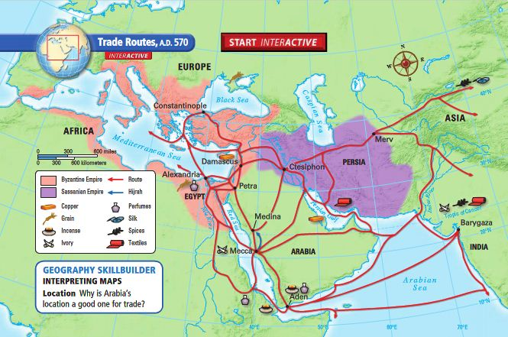Though the Western Roman Empire fell around 450CE the Eastern Roman empire survived, and became known as the Byzantine Empire (named after Byzantium the original city on which Constantine build Constantinople = modern day Istanbul). Though disease also struck the Byzantine Empire it survived until the 15th century (1400s) and was able to preserve Roman culture (e.g. laws, government, architecture, etc.) for people to later rediscover. Part of the reason for this was the fact that the Eastern Roman Empire had strong leaders like Constantine to help run the empire and keep it strong and unified.

