Counter- Reformation
Name: Div.: Date:
Use the following information to answer the questions below.
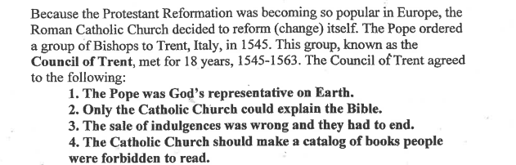
- Describe how each of the points (1-4), from the Council of Trent, were meant to stop people from leaving the Catholic Church, or bring them back.

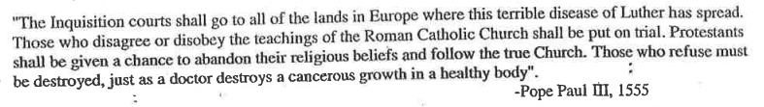
- Based on the quote above, describe the purpose of the Inquisition, and how it would stop the Reformation.

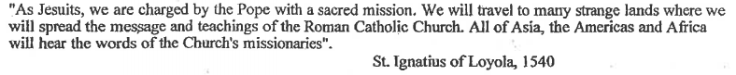
- Based on the quote above, what was the purpose of the Jesuits (How did they help the Catholic Church and its number of followers?

