Atomic Theory Timeline Project
Name: Div.: Date:

Purpose: Visually show the progress of the atomic theory from Dalton to Thomson to Rutherford and Chadwick to Bohr, and finally Schrodinger.

Procedure: Use your textbook (pg. 154- 162) and any other sources you wish to reference to design a timeline that shows the evolution of the model scientists use for the atom.

Criteria:
- Title your timeline/ poster: “Atomic Theory Timeline”
- For each scientist: Dalton, Thomson, Rutherford/Chadwick, Bohr, and Schrodinger include the following:
  - Name and Image of the Scientist
  - Year of discovery / contribution
  - Descriptive Name or Analogy given to their model (i.e. “Nuclear Model”)
  - Accurate diagram of their model

  - Brief explanation of how the model was developed (i.e. Experiment conducted)
  - Brief explanation of the model including changes this model made or problems it solved
  - List some Pros and Cons to each model

Marking:
Inclusion of Basic Criteria (5 Models x 4 bullet points ÷ 2) /10

Explanations + Pros/Cons (5 Models x 3 bullet points x 2pts per) /30
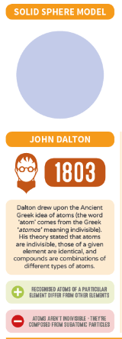
2 | Demonstrated an excellent understanding of how each model was developed, how it changed our understanding of the atom, as well as the strengths and weaknesses of each model.
1 | Demonstrated a basic understanding of how each model was developed, how it changed our understanding of the atom, as well as the strengths and weaknesses of each model.
0 | Not done  OR  Demonstrated very little understanding of how each model was developed, how it changed our understanding of the atom, as well as the strengths and weaknesses of each model.

