Order of Operations

Name: Div.: Date:

B rackets
E xponents

D ivision
M ultiplication
A ddition
S ubtraction

B Do any operations within brackets in the same order with which you would do the rest of the operations.
E Do any exponents/ roots within brackets, then those outside of the brackets before starting on other operations.
DM Do any multiplication, or division, as it shows up from left to right before you do any adding or subtracting (unless they are within brackets)
AS Finally, do any adding, or subtracting, as it shows up from left to right

Example:

$\frac{2^{2} x 5-2({3-1)}^{2}}{2^{2}(3 x 3-3)}$

Brackets (DM) $\frac{2^{2} x 5-2({3-1)}^{2}}{2^{2}(3 x 3-3)}$ $\frac{2^{2} x 5-2({3-1)}^{2}}{2^{2}(9-3)}$
Brackets (A/S) $\frac{2^{2} x 5-2({3-1)}^{2}}{2^{2}(9-3)}$ $\frac{2^{2} x 5-2({2)}^{2}}{2^{2}(6)}$
Note: Do NOT treat a fraction bar as division! Reduce the equation to a simplified fraction.
Exponents $\frac{4 x 5-2(4)}{4(6)}$
Multiply/Divide $\frac{20-2(4)}{4(6)}$ $\frac{20-8}{24}$
Add/Subtract $\frac{20-8}{24}$ $\frac{12}{24}$ $\frac{1}{2}$

Remember: 2(4) = 2 x 4

Order of Operations

Name: Div.: Date:

Solve using proper order of operations. Show your work.

- $7-2 x 3+4÷2 x 5-3$
- $18 ÷3+4-20÷2-5$
- $18 ÷3+4-(20÷2-5)$
- $(1.4+0.8) x 10-5$
- $7 x 9 ÷2(2+20-15)$
- $\left(31-4\right)÷3 x 2-\left(2 x 3+4\right)$
- $[(12 ÷3)+4]-2[14÷2-\left(7-2\right)]$
- $12 ÷4 \left(7-4\right)-5 x 3- (7+3)$
- $[\left(4^{2}-2^{3}\right)÷2]^{2}- 2^{2} x 3+21 ÷3$
- $18 ÷3^{2}+[10÷2(2+3)^{2}]$
- $[(5+3)^{2} x 6]÷3- 3^{2}$
- $[(5-2)^{2} x 6]+2^{2} x 4-18 ÷3$
- $\left(19-4^{2}÷8\right)+1.8 ÷2$
- $3(10-2^{2} x 2) +8-(5-12÷6)^{2}$
- $2^{2}(2 x 2^{2})^{2}-(2^{3} x 2^{3} ÷2^{2})$ *Exponent Laws*
- $\frac{4+(4-2)^{2}-6}{30-2\left(7\right)+4}$
- $\frac{2+(5-1)^{3}+19}{2(2+1)^{2}-1}$
- $\frac{3+(3^{2}-2)^{2}+23}{3(5-2)^{3}-6}$
- $\frac{5+(3+2x6)}{2^{4}÷2^{3}}$
- $\frac{2+3 x 3^{3}- 2^{3}}{1+3 x 2^{3}}$

Add Brackets to make the #21 and 22 true. You may add more than one set of brackets to each equation.

- $2+3 x 4+5=29$
- $2+3 x 4+5=45$
- Explain what is wrong with the following answer: $15-3 x 2=24$

- What is the correct answer (That only 223/863 people chose)?
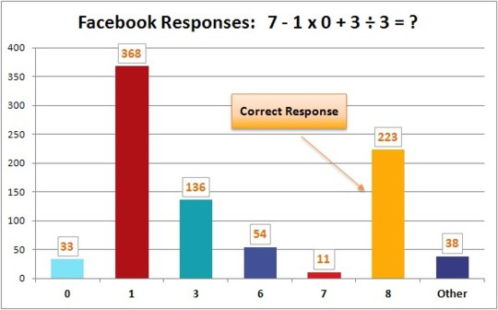

- Explain this meme:
