Subtracting Integers
Name: Div.: Date:
Subtract on a number line by starting at the first number and then moving away from the sign of the number you are subtracting the same number of spaces as the number.
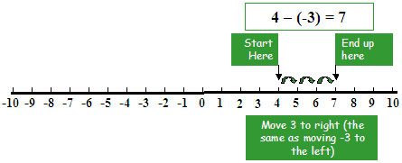
Subtracting means you move AWAY from the sign of the number you are subtracting. E.G. Away from the negative 3 spots.

Subtracting Integers is the same as adding the opposite integer:
$5-2=3$ is equal to $5+(-2)=3$

Subtract using a number line:
- $\left(+4\right)-\left(+3\right)$
- $(+3)-3$
- $(+2)-(-3)$
- $(+5)-(-4)$
- $(-6)-(+6)$
- $\left(-10\right)-6$
- $(-5)-(-3)$
- $\left(-4\right)-\left(-6\right)$

Subtract using an integer tile diagram:
- $\left(+4\right)-\left(+3\right)$
- $(+3)-3$
- $(+2)-(-3)$
- $(+5)-(-4)$
- $(-6)-(+6)$
- $\left(-10\right)-6$
- $(-5)-(-3)$
- $(-4)-(-6)$

Subtract by using opposite operations:
- $\left(+5\right)-\left(+2\right)-\left(+6\right)$
- $\left(-4\right)-\left(+1\right)-\left(+3\right)$
- $\left(-6\right)-\left(-4\right)-\left(+1\right)$
- $\left(-3\right)-\left(+9\right)-\left(-1\right)$

Simplify (Solve).
- $\left(+6\right)-\left(+3\right)+\left(+8\right)-(+2)$
- $\left(-4\right)+\left(+3\right)-\left(+9\right)-(+8)$
- $\left(+7\right)+\left(-3\right)-\left(-3\right)-(+8)$
- $\left(-2\right)-\left(-6\right)-\left(-6\right)+(-8)$
- $7-\left(-2\right)+5$
- $-3+2-(-4)$
- $-4-6+8$
- $5-7+2-3+6$
- $-4+6-1+3-6$
- $-2-3-1+5+7$
- $2-3-5+1+3$

Decide whether each statement is always true, sometimes true, or never true. Explain.
- Adding an integer is the same as subtracting its opposite.
- Subtracting $-2$ from an integer gives a smaller integer.
- Subtracting a negative integer from a negative integer gives a positive integer.
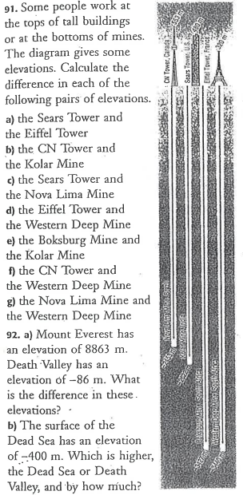
Towers:
CN – 553m
Sear –480m
Eiffel –320m
Mines:
Kolar – (-2622m)
Nova Lima – (- 2453m)
Boksburg – (-3427m)
Western Deep – (- 3440m)

