Plotting Earthquakes, Volcanoes, & Mountains
Name: Div.: Date:

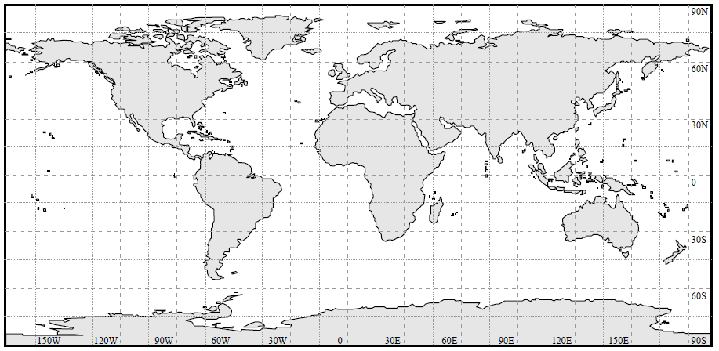

- Connect the points with pencil lines. What do you think these lines represent? (Make a Hypothesis)

- What do you notice about the locations of these geological features? What do you think is happening at the location of mountains, volcanoes, and earthquakes? How are these features related?

- What further information might help us better understand the connection between these features?

- What else could you add to this map to improve our understanding of what is happening?

