Hundred Years War
(1338 - 1453)
Name: Div.: Date:
Use your supplemental booklet pg. 145-148 to answer.
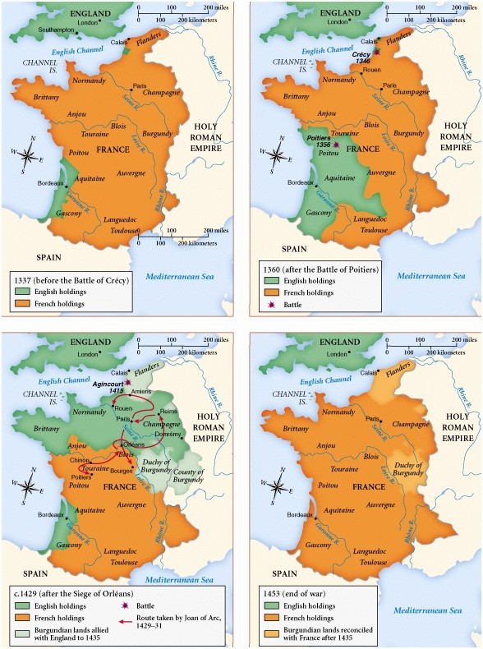
- Using the map to the right give a brief description of what you think happened during the Hundred Years War.

- What technology and tactics allowed England to win battles, such as Agincourt (1415), when they were outnumbered?

Read “The Burghers of Calais” (Burgh means city so Burgher = citizen) and answer the following:
- Who do you think is most chivalrous in the story: The citizens who volunteered to die? The queen who asked for enemies to be pardoned? Or the King who pardoned them? Explain your reasons.

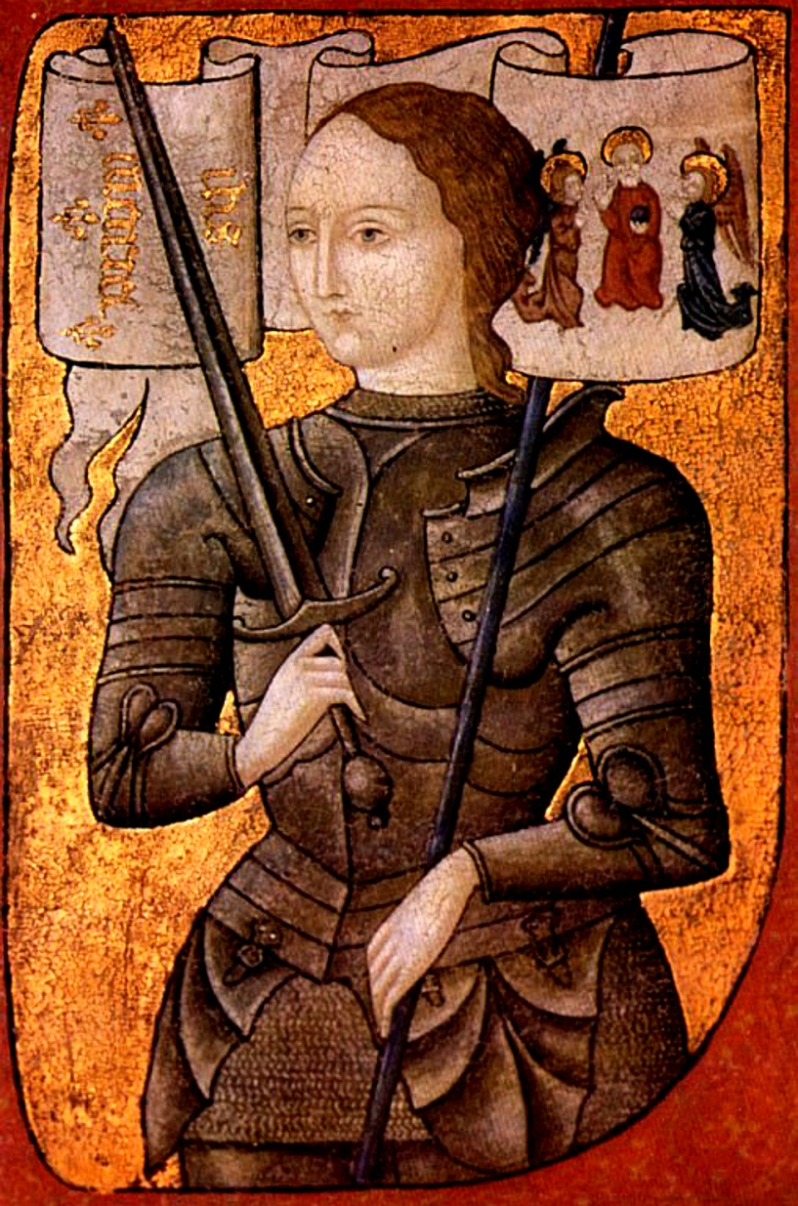
- Create an order of events for Joan of Arc’s life from when she started hearing voices until her death.

- What personality qualities can you infer from Joan’s letter to the English invaders?

- How did the Hundred Years War end feudalism (remember the purpose of a manor)?

