Consequences of Exploration

Name: Div.: Date:

Use the following documents to answer the corresponding questions.

Document 1

Source: As European countries established colonies around the world, an exchange of trade goods across the Atlantic Ocean came to replace the Silk Roads. The trans-Atlantic trade network was known as the Columbian Exchange, after Christopher Columbus. (William Dukier and Jackson Spielvogel, “The Columbian Exchange” as found in World History, 2013)
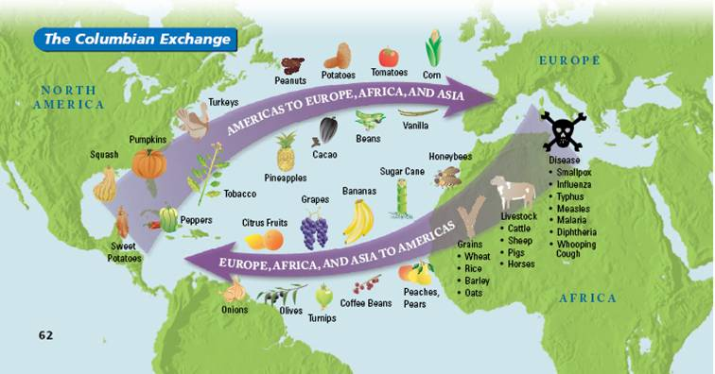

Document 2
Source: Sixteenth-century Aztec drawings of victims of smallpox (above) and measles (below)
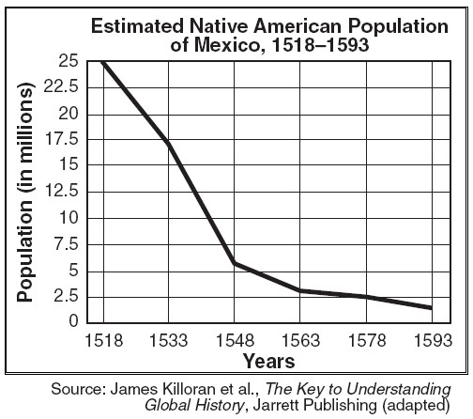
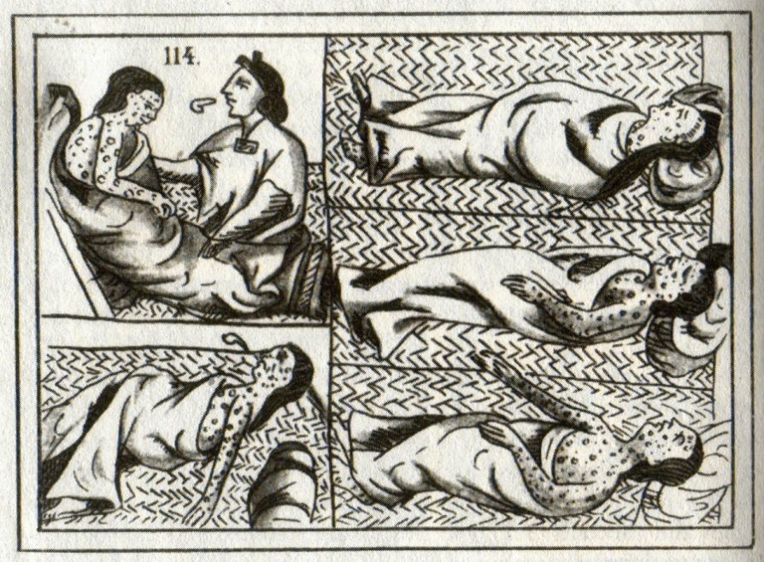
By Unknown - Scanned from (2009) Viruses, Plagues, and History: Past, Present and Future, invalid ID: Oxford University Press, USA, p. 60 ISBN: 0-19-532731-4., Public Domain, https://commons.wikimedia.org/w/index.php?curid=12442514
Document 3
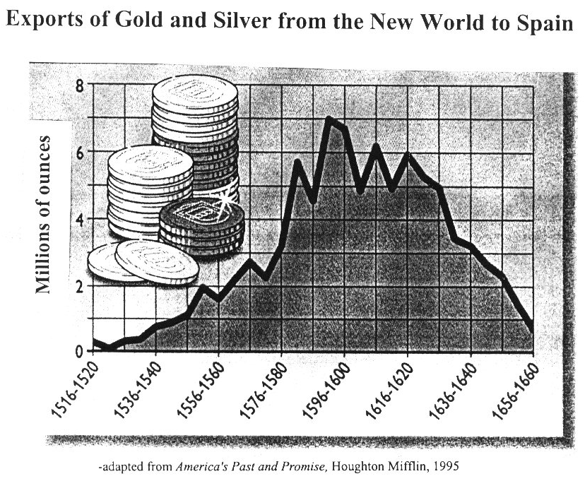

- Based on the above documents fill in the following T-chart with what each group got from the “Columbian Exchange”

Europeans | First Nations

- Who benefitted most from the Columbian Exchange? Why do you think that group benefited more?

Document 4
Source: “Indians in Latin America,” Article written for The World Book, 20th century
During the early 1500’s, Spain established the encomienda system in Latin America. Under this system, the Spanish king granted colonists the right to collect payments from Indians living in certain areas of land. The Spanish landowners forced the Indians to farm the land or work in mines. Eventually, the colonists claimed to own the land. Thousands of Indians died from overwork and harsh treatment.
Spanish threats to Indian ways of life were not limited to forcing them to work for the colonists’ benefit. The Spaniards also weakened traditional tribal bonds by resettling individual members of tribes far apart so that they would have little contact with one another. In some cases, Indians were moved to specially designed villages where they would be forced to give up their customs so they could be taught Christianity and European customs and manners.

Document 5
Source: Bernal Diaz The True History of the Conquest of New Spain, 1517-1519. Translated by Maurice Keantinge, 1800
Let us state how most of the Indian natives have successfully learned all the Spanish trades…There are gold and silversmiths…and carvers also do the most beautiful work with iron tools…Many sons of chieftains know how to read and write, and to compose books…Now they breed cattle of all sorts, and break in oxen, and plough the land, and sow wheat, and thresh harvest, and sell it, and make bread, and they have planted their lands with all the trees and fruits, such as apples and pears which they hold in higher regard than their native plants, which we have brought from Spain.
- What perspective does Document #4 take on the Spanish influence on the Native peoples of Latin America?

- What perspective does Document #5 take on the Spanish influence on the Native peoples of Latin America?

- Compare and contrast the sources for the two documents (e.g. Who? When? Why? Write) and use that to explain why their perspectives on the Spanish are different.

- Which source do you think is more objective/ truthful about the impact of the Spanish on Latin America? Explain why you prefer the perspective of that source.

Document 6
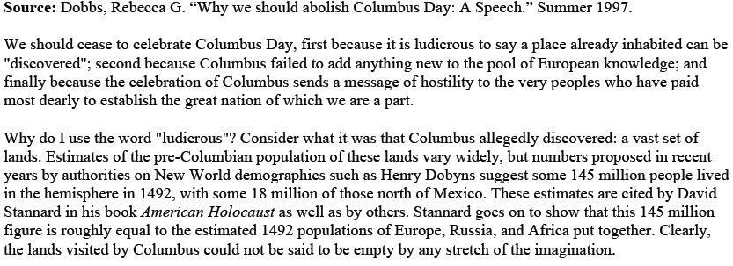

Document 7
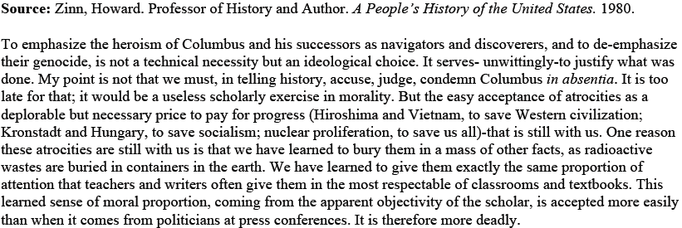

Document 8
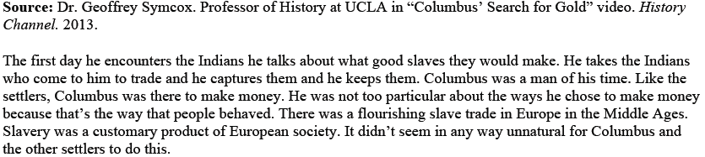

Document 9
Source: Arthur M. Schlesinger, Columbus on Trial, 1918
European culture, like any other large-scale civilization, has produced its share of monsters and atrocities, but other civilizations in their conquests did not show anything like the concern for moral behavior and treatment of others that Europe did in theory if not always in fact. As Arthur M. Schlesinger, Jr., has rightly pointed out: Whatever the particular crimes of Europe, that continent is also the source—the unique source—of the liberating ideas of the individual liberty, political democracy, the rule of law, human rights, and cultural freedom that constitute our most precious legacy and to which most of the world today aspires. In fact, it was precisely the contact with Americas that stimulated Europe to develop further some of the principles we take for granted today as constituting the basic minimum of human rights and proper international conduct.

- How does each source view the Europeans (& Columbus) actions in the Americas? Do they condemn them? Justify them? Or Attempt to understand them?

  - Document #6:

  - Document #7:

  - Document #8:

  - Document #9:

- How does Dr. Symcox’s presentation of his information differ from M. Schlesinger? Why do you think they present the information so differently?

- Why do you think the perspective on European actions in the Americas from 1918 might be so different than those from 1980 and 1997?

- From what you have read, and considered, about the above sources, which perspective on the Europeans actions in the Americas do you agree with most? Why?

