Who Should be King?

Name: Div: Date:

Edward the Confessor died on 5 January 1066. Immediately after his death there was a race in Europe for the crown of England because Edward had no children to succeed him. The three main people claiming the throne were Harold Godwinson (Earl of Wessex), William (Duke of Normandy), and Harald Hardrada (King of Norway). Each one of the men believed they had the best claim to the throne, but they had to convince the Witan (group of noblemen) to vote for them. Use the information on the following pages, plus any extra research, to complete your tasks:

CLAIMANT FACT FILE:
HAROLD GODWINSON
BRIEF DESCRIPTION:
Brother of King Edward the Confessor's wife.
Son of Earl Godwinson, the most powerful noble in England.
Had the support of the Witan.
Claimed to have been made King by Edward.
Was English and popular with many of the people.
Had been involved in running the country for years.
Had experience of government and control of an army.
CLAIM:
Harold Godwinson had a great deal of power by 1066. His father had died, so he was now head of the powerful Godwin family.
When King Edward the Confessor lay dying in early January 1066, his wife Edith and Harold Godwinson were at his bedside. According to Harold, King Edward's dying words were:
"I commend my wife and all my kingdom to your care"
If this was true, Harold had a rightful claim as he was carrying out the King's last wish.
PROBLEMS WITH THE CLAIM:
Did the words really mean King Edward wanted Harold to become King? Was Edward just asking Harold to look after his wife? Why did Edward suddenly change his mind?
Do we believe Harold? His only proper witness was his sister! There were probably others there, but nobody who would have been prepared to go against Harold.
Harold was crowned King very quickly after King Edward's death. Usually there would be a period of mourning. Was Harold trying to rush because he was covering something up?
If King Edward's dying wish was for Harold to become King, then Harold had the rightful claim. A King's dying wish replaced all previous promises or plans.

CLAIMANT FACT FILE:
WILLIAM DUKE OF NORMANDY
BRIEF DESCRIPTION:
Was the cousin of King Edward the Confessor.
Claimed that Edward promised him the throne in 1051.
Claimed that Harold of Wessex also promised him the throne.
Had been a very successful as ruler of Normandy.
Claimed that he could repeat the job as King of England.
CLAIM:
Said King Edward the Confessor promised him the throne. In 1016, when King Canute invaded England, young Edward was protected by Normandy.

When Edward took the throne of England, in 1042, William sent troops to England to help protect Edward.

According to William, King Edward promised him the throne in 1051 to thank him for his help and to solve the succession problems.
PROBLEMS WITH THE CLAIM:
Norman sources say Harold Godwinson was sent by King Edward to swear an oath of support in 1064.
Saxon sources say Harold was shipwrecked off Normandy and that William held Harold’s nephew hostage until he swore loyalty to him.

CLAIMANT FACT FILE:
HARALD HARDRADA
BRIEF DESCRIPTION:
Was the King of Norway.
A descendant of King Canute of England.
Claimed his family was promised it could rule England.
Was frequently at war and usually won.
Collected lots of taxes from his people to pay for wars. Very unpopular, but powerful.
CLAIM:
Harald claimed that he had a right to the English throne. Many Vikings had settled in Northern England in the 860s (Danelaw was given to Vikings to stop other raids) and wanted Harald to be king.
Harald was also related to King Canute, the King of England, Denmark, and Norway from 1016-1042. Harald said Edward stole the throne from Canute and he had every right to rebuild Canutes great Viking Empire.
Harald also had Harold’s brother Tosig giving his support.
PROBLEMS WITH THE CLAIM:
He relied on his Viking reputation of being fierce. He was a tremendous warrior, and had travelled across and beyond Europe. Harold Hardrada was a true Viking, and wanted to take England by force.

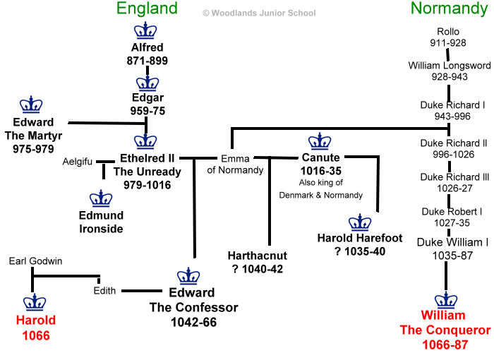

Imagine if television had been around at this time? You are going to be put into three groups; each supporting one of the claimants.

Each group will:
- Hand in their rough notes with their research information on each of the three candidates
  - You will include a list of where you obtained your information
    - Website: URL, Date Accessed, Author
    - Book: Title, Author, Year Published

- Create three campaign videos (30sec-2min each):
  - One ad promoting your candidate.
  - Two “attack” ads
    - One for each of the other candidates stating why they would be a bad choice.

Marking

- Group Member Evaluations 5 marks
      - Based on Rubric on following page
        - Confidential
          - Only Mr. Howe will see your marks for your partners
          - Mr. Howe reserves the right to alter Group Member evaluations

- Works Cited List 5 marks
  - List of where you got your information
  - In proper MLA formatting

- Videos 15 marks (5marks x 3 Videos)
  - Based on Rubric below
Total 25 marks

Video Rubric

1 | - The videos demonstrate that the group appears to have done little to no research on the three candidates.  - All of the videos are not very engaging.
2 | - The video demonstrates that the group appears to have done minimal research on all three of the candidates.  - Some of the videos are not very engaging.
3 | - The video demonstrates that the group appears to have research on all three of the candidates.  - All of the videos are engaging.
4 | - The video demonstrates that the group appears to have done considerable research on all three of the candidates.  - The video is entertaining to watch, and demonstrates a recognition of some common techniques used in political ads.
5 | - The video demonstrates that the group appears to have done extensive research on all three of the candidates.  - The video is entertaining to watch, and demonstrates a strong grasp of common techniques used in political ads.

Group Evaluation Rubric

 | Effort | Attitude | Contribution
5 | Produced additional resources for the group; extraordinary effort demonstrated | Exceptionally positive and constructive; Did their work without complaint. | Outstanding contribution; above-and-beyond; work is excellent.
4 | Fully prepared; completed all tasks asked of them, plus a little more. | Positive; supportive; mostly constructive and upbeat | Good quality work; very few revisions or additions are necessary.
3 | Did all work asked of them; competent, but not extraordinary | Neutral; neither encouraging nor discouraging. | Okay quality work; some revisions or additions are necessary.
2 | Minimal preparation; superficial knowledge of information; minimal effort | Disinterested in the project and their performance. | Poor quality work; lots of errors; lots of editing is required
1 | Little effort shown | Disparaging; negative, withdrawn or belligerent; absent | Poor quality; little, if any, contribution to group

Group Members: | Effort (5) | Attitude (5) | Contribution (5) | Total (15)
Your Name: | - | - | - | -

