Who Should be King?
Name: Div.: Date:

Edward the Confessor died on 5 January 1066. Immediately after his death there was a race in Europe for the crown of England because Edward had no children to succeed him. The three main people claiming the throne were Harold Godwinson (Earl of Wessex), William (Duke of Normandy), and Harald Hardrada (King of Norway). Each one believed they had the best claim to the throne. Use the information on the following pages, plus any extra research, to complete your tasks:

CLAIMANT FACT FILE:
HAROLD GODWINSON
BRIEF DESCRIPTION:
Brother of King Edward the Confessor's wife.
Son of Earl Godwinson, the most powerful noble in England.
Had the support of the Witan.
Claimed to have been made King by Edward.
Was English and popular with many of the people.
Had been involved in running the country for years.
Had experience of government and control of an army.
CLAIM:
Harold Godwinson had a great deal of power by 1066. His father had died, so he was now head of the powerful Godwin family.
When King Edward the Confessor lay dying in early January 1066, his wife Edith and Harold Godwinson were at his bedside. According to Harold, King Edward's dying words were:
"I commend my wife and all my kingdom to your care"
If this was true, Harold had a rightful claim as he was carrying out the King's last wish.

PROBLEMS WITH THE CLAIM:
Did the words really mean King Edward wanted Harold to become King? Was Edward just asking Harold to look after his wife? Why did Edward suddenly change his mind?
Do we believe Harold? His only proper witness was his sister! There were probably others there, but nobody who would have been prepared to go against Harold.
Harold was crowned King very quickly after King Edward's death. Usually there would be a period of mourning. Was Harold trying to rush because he was covering something up?
If King Edward's dying wish was for Harold to become King, then Harold had the rightful claim. A King's dying wish replaced all previous promises or plans.

CLAIMANT FACT FILE:
WILLIAM DUKE OF NORMANDY
BRIEF DESCRIPTION:
Was the cousin of King Edward the Confessor.
Claimed that Edward promised him the throne in 1051.
Claimed that Harold of Wessex also promised him the throne.
Had been a very successful as ruler of Normandy.
Claimed that he could repeat the job as King of England.
CLAIM:
Said King Edward the Confessor promised him the throne. In 1016, when King Canute invaded England, young Edward was protected by Normandy.

When Edward took the throne of England, in 1042, William sent troops to England to help protect Edward.

According to William, King Edward promised him the throne in 1051 to thank him for his help and to solve the succession problems.
PROBLEMS WITH THE CLAIM:
Norman sources say Harold Godwinson was sent by King Edward to swear an oath of support in 1064.
Saxon sources say Harold was shipwrecked off Normandy and that William held Harold’s nephew hostage until he swore loyalty to him.

CLAIMANT FACT FILE:
HARALD HARDRADA
BRIEF DESCRIPTION:
Was the King of Norway.
A descendant of King Canute of England.
Claimed his family was promised it could rule England.
Was frequently at war and usually won.
Collected lots of taxes from his people to pay for wars. Very unpopular, but powerful.
CLAIM:
Harald claimed that he had a right to the English throne. Many Vikings had settled in Northern England in the 860s (Danelaw was given to Vikings to stop other raids) and wanted Harald to be king.
Harald was also related to King Canute, the King of England, Denmark, and Norway from 1016-1042. Harald said Edward stole the throne from Canute and he had every right to rebuild Canutes great Viking Empire.
Harald also had Harold’s brother Tosig giving his support.
PROBLEMS WITH THE CLAIM:
He relied on his Viking reputation of being fierce. He was a tremendous warrior, and had travelled across and beyond Europe. Harold Hardrada was a true Viking, and wanted to take England by force.

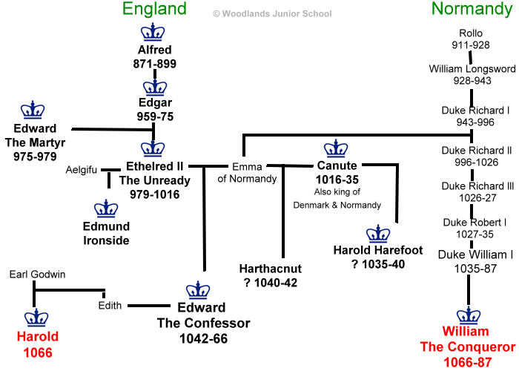

Tasks

- Create a chart of each person’s claim to the throne.

- Create a chart of the weaknesses of each person’s claim to the throne.

- Based on the information in your two charts above, write a letter to the Witan (English council), as the person you think has the best claim to the throne, explaining your position, and the reasons they should support you over the other claimants.

  - Dear most noble and wise men of the Witan,
I am writing this letter to you to apply for the post of King of England, which has recently become available due to the death of Edward the Confessor. I believe that I, …

