Wavestown

Name: Div.: Date:

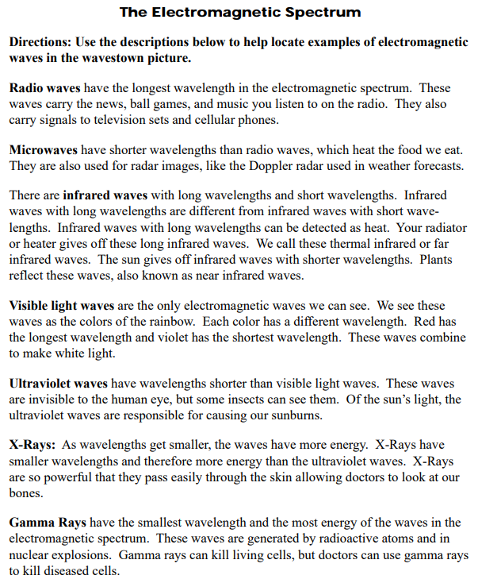

Red

Orange

Yellow

Green

Blue

Indigo

Violet

* You can use the above colours to shade in the picture or just highlight / number the image

