Surface Area of Right Triangular Prisms
Name: Div.: Date:
Draw the 3D net and label its parts to help solve the following questions
 | 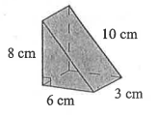 |  | 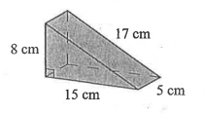
 | 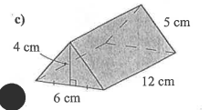 |  | 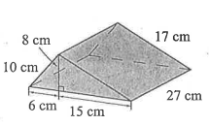
 | Michael wants to build a jump ramp and now he wants to paint it. If the jump has a width of 95cm and the sides of the right triangle are 60 cm by 80 cm with a hypotenuse of 100cm. What is the surface area he needs to paint (assume he will paint all sides)? |  | The school made a new door wedge to keep the gym doors open during assemblies, now they want to paint it the school colours. If the wedge has a width of 6cm and the sides of the right triangle are 6 cm by 8 cm with a hypotenuse of 10cm. What is the surface area they need to paint?
 | The total surface area of a triangular prism is 18mm. The triangular base is an equilateral triangle with a base of 4mm and a height of 3mm. Find the length of the prism. |  | How big of a box do you need for a Toblerone that is 10cm long by 5cm across and 3cm high?

