Surface Area of Rectangular Prisms
Name: Div.: Date:
Draw the 3D net and label its parts to help solve the following questions
 | 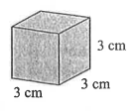 |  | 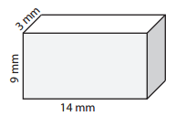
 | 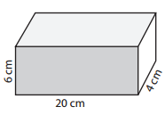 |  | 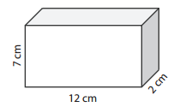
 | 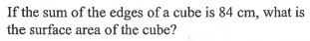 |  | If the surface area of a cube is 150cm², what are the lengths of the sides of the cube.
 | 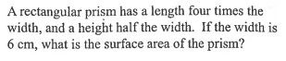 |  | 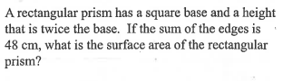
 | 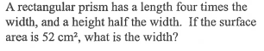 |  | If the edges of a cube are doubles in length, what happens to the surface area? What if they are tripled in length? Write a mathematical equation to show what will happen to the surface area if the sides are increased by a factor of $n$.

