Line (Cycle) Passing
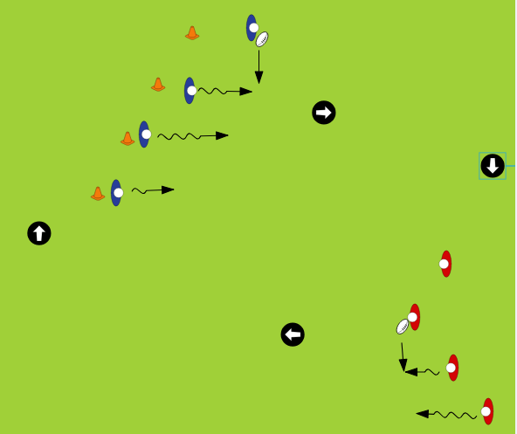
Warm Up Staggered Cones and players pass parallel to themselves as teammates run on to the pass. When the ball is in the middle two lines it should be more V shaped (whoever has the ball should be in front of everyone else and the rest on diagonals away from him/her. When the ball gets to the other end of your group pass in the other direction to continue down field.

Cross Passing
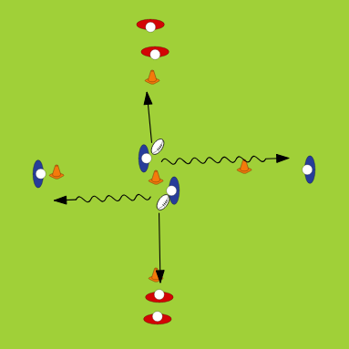
Players facing each other run out to the middle cone pass to their left and continue to the opposite line (Blue Players will always be in those two lines!). Then the two red players will run out to the middle cone and pass to their left. Switch to passing to the right after a few minutes.

2 on 1 (Continuous)
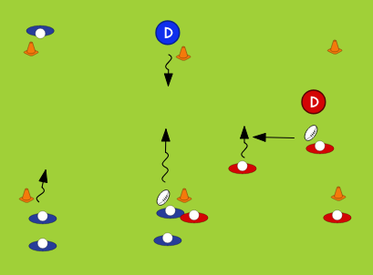
Set up 10 by 10 grids. Defender stays on back line until the offensive pair goes. Offence just has to get the ball to the other side. Any fouls or intercepted passes = fail. To make it continuous (blue team) have two people on the defensive side and only one of them goes (D). No matter what happens the defender (D) and the waiting player on his side then go 2 on 1 in the other direction vs one of the waiting partners at the bottom of the diagram. The two that just went should be waiting at the top.

3 on 2 (Continuous)
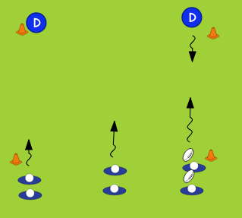
Same as 2 on 1 but make a slightly larger area (15 by 15). Ball can start in any line. If you want to work on the longer spin pass

