The Church Breaks Up?

Name: Div.: Date:

Answer the following questions using pages 338-350 in your textbook.
- Describe what happened during the “Great Schism,” and how it weakened the Roman Catholic Church’s control.

- Describe some of the other factors that lead to the decline in power of the Roman Catholic Church (Use “How to Get Rich…” to add any further details).

- What revelation caused Martin Luther to publish his 95 Theses? What was the purpose of the 95 Theses?

- Describe the events from after Luther posted his 95 Theses to the creation of Lutheranism.

- What allowed Protestantism to spread quickly? Why did Protestantism become popular with some German Princes?

- Describe how the Calvinist religion began.

- What are some of the beliefs, and practices of Calvinism?

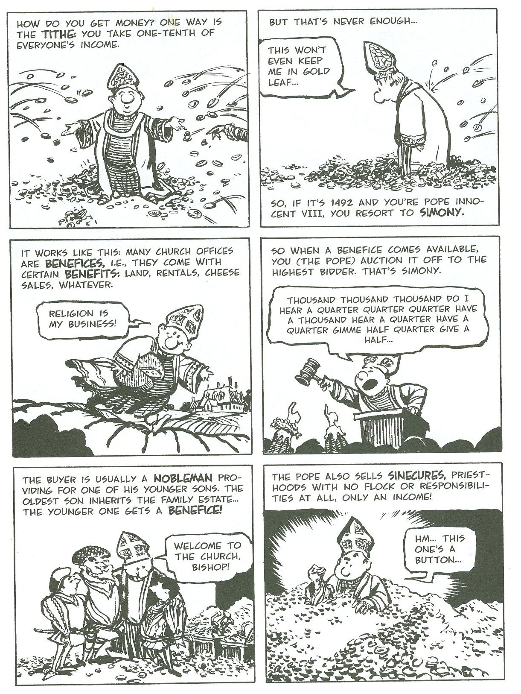

How to Get Rich in the Old Catholic Church!

