Volleyball Notes
Name:

Skills:
- Ready Position
  - Down Low/ Slight Lean Forward
  - Feet Apart – One in front of other slightly
  - Arms out with slight bend (think: holding baby with dirty diaper)

- Forearm Pass
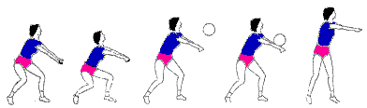
  - Thumbs together Flat Arms
  - Contact out in front with forearm
  - Shoulders + Legs move on pass NOT Arms

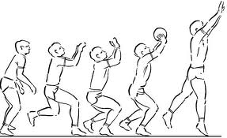
- Overhead Pass
  - Triangle above eyebrows (Fingers spread)
  - Pads of hands cushion ball (no palm)
  - Extend legs and arms out to push the ball

- Serve
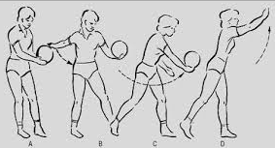
  - Hit with the palm of the hand
  - All movement & momentum in direction of serve
  - Follow through to target (finish high = high serve)

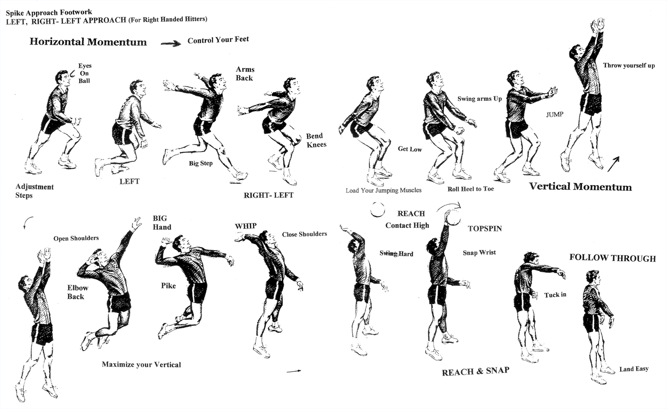
- Spike

Volleyball Court/ Team set up:
- Six players on the court at one time
- Players on front of the attack line may attack in any method (2-4)
- Players behind the attack line can only jump when behind the attack line to attack (1-6)
- The Player in position #1 is the server
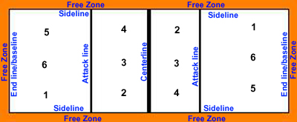

General Volleyball Rules:
- Once the play is started, with a serve, each team has three hits to get the ball over the net to the opposing team. Play stops when the ball hits the ground, goes out of bounds, or is hit more than three times by a team.

- If the ball lands in your opponent’s court your team gets a point. If your team hits the ball out, your opponent gets a point (Rally Point).
  - If your opponent touches the ball before it goes out though, it is your point!

- The ball must enter your opponent’s court from inside the sidelines (antennae are attached to the nets to extend the sidelines for this purpose); however, you may make contact from anywhere to do so. E.G. you may be in the “Free Zone” and hit the ball into your opponents court, as long as it enters while between the sidelines.

- You cannot attack a serve (block, or spike)!

- You cannot intentionally block an opponent’s view.

- You must release the ball before serving. You can’t hit it out of your hand.

- The server may server from any position along the baseline, as long as he/she makes contact while between the sidelines.

- If the ball hits the roof, play continues unless it was an attempt to send the ball over the net (3rd Hit for a team, or a serve).

- Four hits: Your team is only allowed a maximum of three hits before they must return the ball to the opponent. However, a block does not count as a hit since you are still on defense!

- Two/Double Hit: A player may only contact the ball with both hands at the same time! If the ball rolls up your arms or hits one arm and then the other it is a double hit, or if a player tries to hit the ball twice in a row.

- Carry: If the ball stays in a player’s hands, while setting, for too long it can be called a carry, or hits the palms of the hands while setting. Also, if you have your hands open during a forearm pass and the ball hits the palms it will be called a carry. It is shown by the ref by showing an open palm (like she is carrying a tray) and then raising her arm up as though she is lifting something.

- Net Violation: You may hit the net, as long as it does not interfere with play of your opponent, but most contact with the net will be a violation. You may NOT step under the net into your opponent’s court.

- Foot fault: If the serving player touches the end line before he/she hits the ball (you can jump over it as long as you hit the ball before you land).

- Back row attack: If a back row player hits the ball above the height of the net while also in front of the attack line (3m line).

