1) The Mongols would force captured enemies to march in front of their troops using them as human shields. These captives would also push siege engines to the walls of a city, and in one instance were pushed into a moat to fill it as they besieged a city. - John of Plano Carpini, “History of the Mongols” (1240)

2) (1200) Temujin decimating the Tatar army, and ordered the killing of every Tatar male who was taller than a wagon wheel (3 feet). - Secret History of the Mongols (1230-40s)

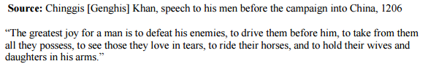
3)

- Secret History of the Mongols (1230-40s)

4) (1220) “The people of Samarkand (Khwarezmid) were ordered to evacuate and assemble in a plain outside the city, where they were killed and pyramids of severed heads raised as the symbol of Mongol victory.” (100,000 killed) - Persian historian Juzajani “Tabaqat-i Nasiri” (1260)

5) (1220) The artisans were sent back to Mongolia, young women and children were given to the Mongol soldiers as slaves, and the rest of the population was massacred. The Persian scholar Juvayni (1260s) states that 50,000 Mongol soldiers were given the task of executing twenty-four Urgench (Khwarezmid) citizens each, which would mean that 1.2 million people were killed. While this is almost certainly an exaggeration, the sacking of Urgench is considered one of the bloodiest massacres in history.

6) The Mongol captured Herat (Khwarezmid), in 1221. The inhabitants were initially spared. But when they rose in revolt Genghis Khan told one his generals, "Since the dead have come to life, I command you to strike their heads from their body." Reportedly only 40 of the city's inhabitants survived (of 200k – 1.6million) - Juvayni

7) After the husband of Genghis Khan’s daughter, Taghachar, was killed at Nishapur (Khwarezmid) in 1221 by a Nishapur Muslim border guard, Genghis Khan ordered the death of all in the city—500,000 to 1.7 million were killed, and the skulls of men, women, and children were piled in pyramids by the Mongols. - Persian historian Juzajani “Tabaqat-i Nasiri” (1260)

8) (1221) The Persian historian Juvayni, writing a 40 years after the destruction of Merv (Khwarezmid), wrote: "The Mongols ordered that, apart from four hundred artisans. .., the whole population, including the women and children, should be killed, and no one, whether woman or man, be spared. To each [Mongol soldier] was allotted the execution of three or four hundred Persians. So many had been killed by nightfall that the mountains became hillocks, and the plain was soaked with the blood of the mighty."
9) After seizing all of western Khwarazm, Genghis Khan returned to the kingdom of Xi Xia near Tibet. After the Mongols finally captured the city of Tangut in a brutal, hard-fought battle, the Tangus rulers and most of the citizens are killed. Khan reportedly ordered the extermination of the Xi Xia people and his army reportedly killed "mothers and fathers down to the offspring." So complete was the defeat that for all intents and purposes Xi Xia disappears from history. - Secret History of the Mongols (1230-40s)

10) The Mongols celebrated a victory over the Russians by laying survivors on the ground, dropping a heavy wooden gate on them, and then having a victory banquet on top of it while the victims suffocated and crushed to death. - Secret History of the Mongols (1230-40s)

11) In 1258 Hulagu Khan stormed Baghdad. The city which had been the metropolis of Islam for more than five centuries was given over to plunder and flame. The massacre, according to Diyarbakri in his Tarikh al-Khamis, continued for thirty-four days during which 200,000 to 1,800,000 persons were put to the sword. For days blood ran freely in the streets of Baghdad and the water of the Tigris was dyed red for miles. According to Wassaf, the sack of Baghdad lasted forty days, and “the waters of the Tigris ran black with ink from the enormous quantities of books flung into the river.” The caliph of Baghdad, Al-Musta'sim, was captured and forced to watch as his citizens were murdered and his treasury plundered. According to most accounts, the caliph was killed by trampling. The Mongols rolled the caliph up in a rug, and rode their horses over him, as they believed that the earth would be offended if it were touched by royal blood.

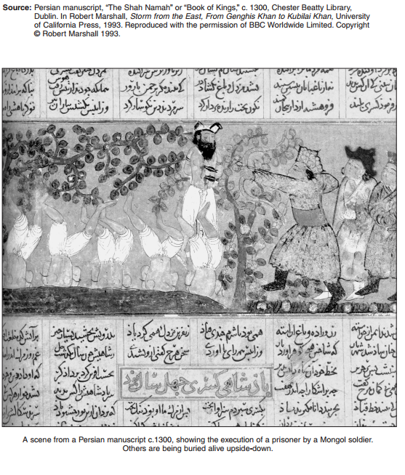
12)

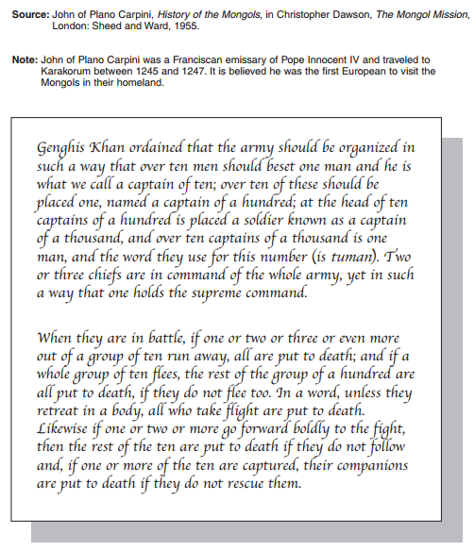
13)

