What is Light?

Name: Div.: Date:

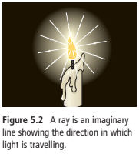
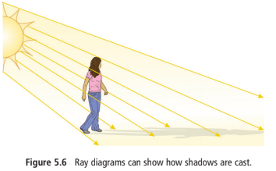
Isaac Newton theorized that light was made up of tiny particles like atoms, which travel all directions from the source of light. This “Particle Model” clearly explained how shadows worked and why light would reflect off shiny objects (light particles bouncing off the object and in the other direction).

Thought experiment #1: If you roll marbles from two corners of a box so that their trajectory crossed paths (x pattern) what would happen with some of the marbles?

Does this happen with light? Test it with flashlights or lasers.

Thought experiment #2: If you roll marbles through a small slit (openning) in a barrier diagram how would the marbles hit on the opposite wall?

How does light appear on an opposite wall when passed through a small slit? What do you think this means?

Research how noise cancelling headphones work and Young’s double slit experiment. How does that technology, the results of Young’s double slit experiment, and the result of light passing through a single slit NOT support light being a particle. So, what do you think light is?

Photoelectric Effect

NAME: Div.: Date:

In 1887, Heinrich Hertz discovered that under certain conditions light could expell electrons from a variety of metals. This was called the photoelectric effect. One mystery to the photoelectric effect was the fact that a dim blue light could expell electrons, but not a incredibly bright red light.

Thought Experiment:
If you cook something at 20 degrees celcius versus 40 degrees celcius will the food still cook?

Thought Experiment:
A hose has a blockage at the nossle. What will eventually happen?

Thought Experiment:
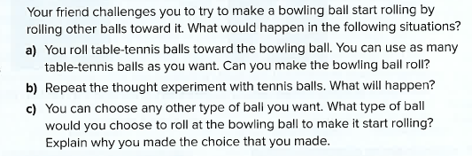

Research:
Explain why only some light produces the photoelectric effect, and what the photoelectric effect proves about light.

