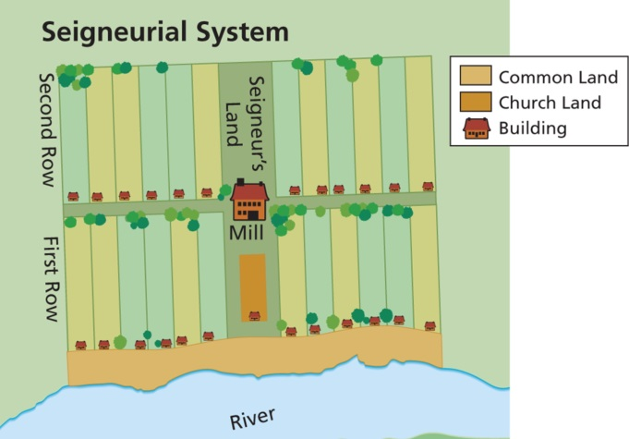
Life in New France

Name:
Div.:
Date:
Use the “Life in New France” textbook pages to answer the following questions:

- Create a T-chart to compare the duties of the Seigneurs and habitants.

- Describe the life of the Habitants, by season.

- Create a list of Pros and Cons to moving to New France to live as a Habitant versus staying on a feudal farm in France. Explain where you would choose to live and why.

- Describe what life was life for women in New France? How was it similar and different from life in (Old) France?

- From the power points and previous information we have covered in class, about women immigrating, why was there a surge of immigration in mid to late 1600s.

