FRENCH

Goal: Negotiate for the best possible price for Furs to get as many furs as possible. But, you don’t know when the furs will run out so don’t wait too long or there might not be any for you.

- You can negotiate with the Huron, Haudenosaunee, and Coureur de Bois
- Materials you have to bargain with (total):
  - 10 Kettles
  - 10 Hatchets
  - 20 Yards of Cloth
  - 4 Guns

ENGLISH

Goal: Negotiate for the best possible price for Furs to get as many furs as possible. But, you don’t know when the furs will run out so don’t wait too long or there might not be any for you.

- You can negotiate with the Huron, Haudenosaunee, and Coureur de Bois
- Materials you have to bargain with (total):
  - 10 Kettles
  - 10 Hatchets
  - 20 Yards of Cloth
  - 4 Guns

COUREUR DE BOIS

Goal: Negotiate for the best possible price for Furs with the First Nations to get as many furs as possible. You don’t know when the furs will run out so get as many as you can as quick as you can.

- You speak native languages and have intermarried with the natives so they trust you more than the French or English. You also travel out to the First Nations rather than them coming to you. So, you get your own round.
- You can negotiate with everyone!
- Materials you have to bargain with (total):
  - 6 Kettles
  - 6 Hatchets
  - 10 Yards of Cloth
  - 2 Guns

HURON

Goal: You want to get as many of the new European goods as possible for your furs. Metal tools are more effective and last longer than those you make. Wool cloth are also useful and Guns can be used to fight off your enemies the Haudenosaunee and defend your land from European’s too.

- You can talk to the French, English, Coureur de Bois, and Ojibwa. (Try to play the French and English off each other to get the most stuff out of them)
- Priority will be given to the Coureur de Bois, but guns to go against the Haudenosaunee is also a big selling point.
- Materials you have to bargain with (total):
  - 20 Furs
  - 2 Kettles
  - 2 Hatchets
  - 5 Yards of Cloth

HAUDENOSAUNEE

Goal: You want to get as many of the new European goods as possible for your furs. Metal tools are more effective and last longer than those you make. Wool cloth are also useful and Guns can be used to fight off your enemies the Huron and defend your land from European’s too.

- You can talk to the English, French, Coureur de Bois, and Ojibwa (Try to play the French and English off each other to get the most stuff out of them)
- Priority will be given to Coureur de Bois, unless a nation is willing to give you guns to help destroy your enemies the Huron.
- Materials you have to bargain with (total):
  - 20 Furs
  - 2 Kettles
  - 2 Hatchets
  - 5 Yards of Cloth

OJIBWA

Goal: You want to get as many of the new European goods as possible for your furs. Metal tools are more effective and last longer than those you make. Wool cloth and guns are also useful.

- You have 80 furs
- You can talk to the Huron and Haudenosaunee to start

Pre-Play Prep
European Goods | Cost
1 Kettle | $1
1 Hatchet | $1
1 Yard Cloth | $2
1 Gun | $8
1 Beaver Pelt | $4

- Have the Europeans start in the Hall to explain that they just want furs! You don’t know how many furs there will be so you need to make sure you get some for your business to stay afloat. If you wait too long you could be out of luck. The pricing should help them figure out deals, but Europeans want to end up with all the furs they can get.

- Leave the Europeans in the hall to plan their own pricing in their groups. Speak to the Indigenous groups:
  - They want European goods and have lots of furs so they want to trade for many European resources since they can get more furs from the Ojibwe

Round #1
Spring
- Coureur de Bois enter the class first to trade with the Huron and Haudenosaunee who are stationed at the doors (2 min)
- Coureur de Bois return to the hall to trade pelts to French and English traders while Huron and Haudenosaunee trade with Ojibwa for more furs back in the class.

Summer
- The French, English, and Coureur to trade with the remaining members of the group (5 min)

Round #2
Spring
- Coureur de Bois go out to any Indigenous populations (Including Ojibwa) to trade for furs (2 min)
- Coureur de Bois return to trade pelts to French and English traders {get more goods for the following season} (3 min)

Summer
- French and English travel to trade with any Indigenous group (10 min)

Bonus Round

- Indigenous groups with guns can raid and steal furs from other groups. 1 gun = 10 furs If both sides have guns then they cancel out (Haudenosaunee have 2 to Huron 1 = 10 furs from Huron to Haudenosaunee)

Round #3

- Open trading between groups (5 min)

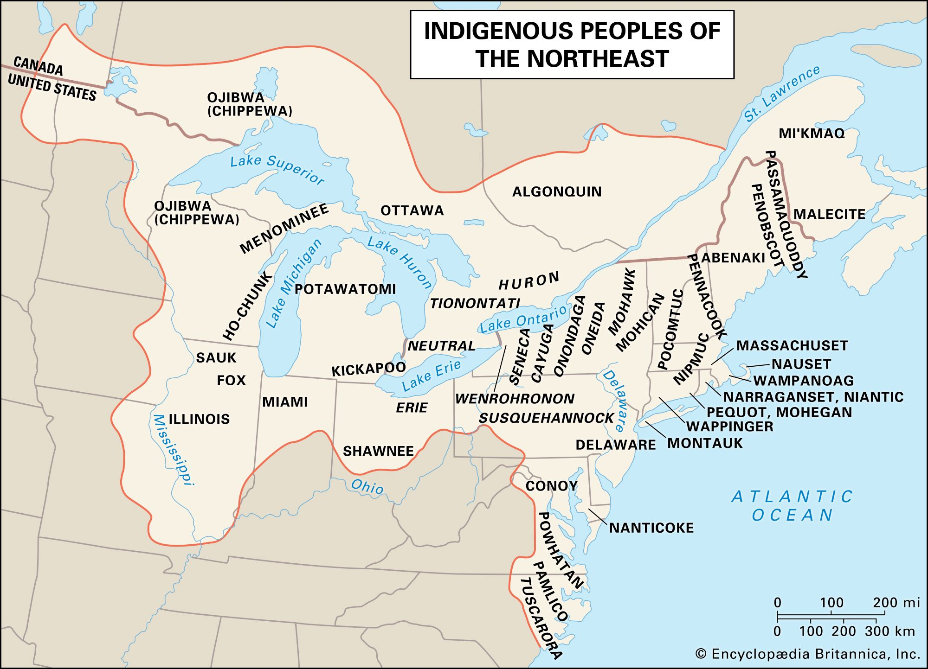
Landscape of Fur trade
French
English

From: The University of Alberta Museums Muse Project

Replace NWC with French, HBC with English, Haudenosaunee with Haudenosaunee, and Ouendat with Huron

