Basketball Skills Notes

Name: Date:

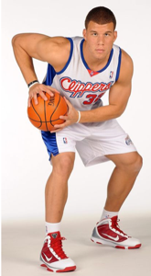
- Triple Threat (Ready) Position
  - Hold the ball tight to the body with your shooting form (90 degree elbow & wrist flexed)

  - Legs are bent and ready to move Feet Shoulder width with one foot in front of the other.

  - Called Triple threat because from this position one may pass, shoot or dribble.

- Passes:
  - Chest
    - Both hands on the ball holding it to your chest (hence name)

    - Step towards and extend arms to target (teammates chest) push ball away

    - Follow through to finish with thumbs pointing to target (create backspin)

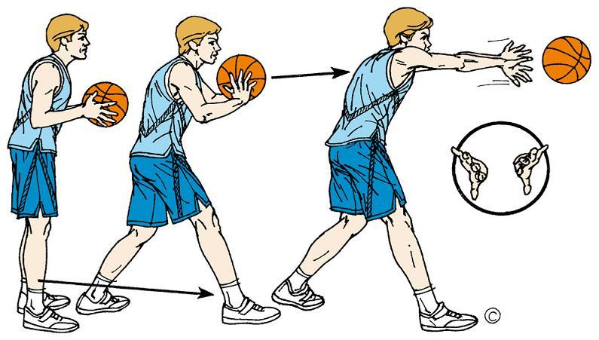

  - Bounce
    - Same as the chest pass; however, your target is now the floor about$\frac{2}{3}$ of the way to your teammate.
    - Your follow through (thumbs) should create backspin that will cause the ball to rise after the bounce.
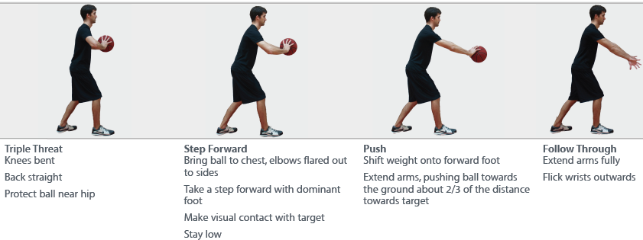
- Shooting:
  - Ball rest in the pads of the shooting hand (NO Palm Touching) with your wrist back like a waiter holding a tray on her shoulder.
    - Ball should be just in front of your face, or on the shoulder whatever feels comfortable
    - Opposite hand just helps balance and guide the ball to go straight Should be barely touching
  - Extend into your shot – start with legs (most powerful and should be used most), then arm up at about a 45 degree angle
  - Follow through to your target by snapping/flexing your wrist as if you are reaching into a cookie jar.
    - Ball should come off the finger tips to create backspin
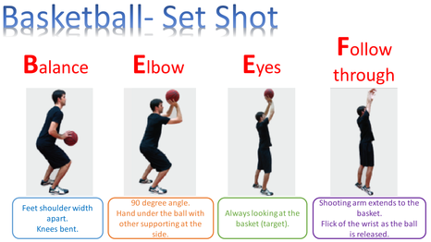
- Lay Up Use your same shooting form as above:
  - Dribble towards where the hoop and backboard are attached at a 45 degree angle from the backboard
  - Extend as high as you can up to the basket with your shooting hand and leg, for the side of the basket you are on (left hand + leg for left side; right hand + leg for right side)
  - Aim for the near top corner of the small rectangle painted on the backboard (top left on left side, etc.)
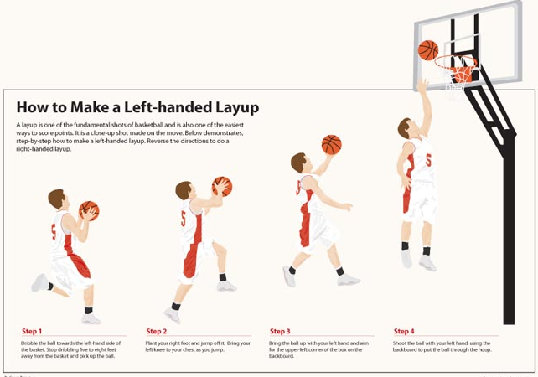

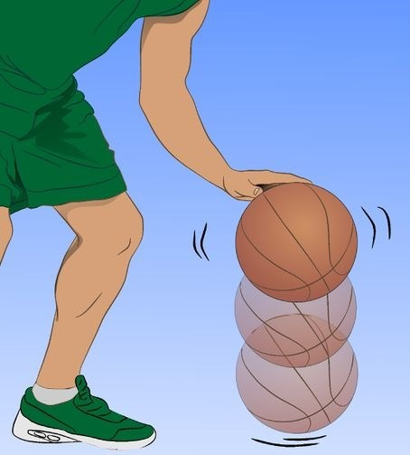
- Dribbling:

  - Contact with the ball is pads of hand (NO PALM)

  - Keep the ball close to the body for controlled dribble Just in front of the outside of your feet

  - Push the ball down into the ground (slightly in front of you; in the direction you wish to go)

    - Push further in front if there is no one there (break away), and run on to the ball

