Adding Fractions
Name: Div.: Date:

Solve the following problems.
Put your answers into lowest terms, with mixed numbers (where possible):
 | 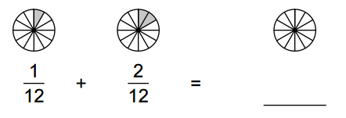
 | 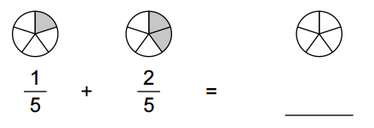
 | 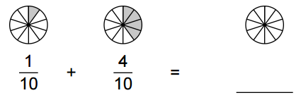
 | 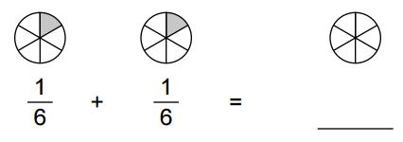
 | $$\frac{9}{11}+\frac{7}{11}=$$ |  | $$\frac{7}{12}+\frac{7}{12}=$$
 | $$\frac{2}{5}+\frac{4}{5}=$$ |  | $$\frac{7}{8}+\frac{5}{8}=$$
 | $$\frac{3}{4}+\frac{1}{5}=$$ |  | $$\frac{3}{7}+\frac{5}{8}=$$
 | $$\frac{2}{3}+\frac{1}{2}=$$ |  | $$\frac{5}{6}+\frac{1}{5}=$$
 | $$\frac{2}{3}+\frac{1}{9}=$$ |  | $$\frac{2}{5}+\frac{1}{10}=$$
 | $$\frac{3}{14}+\frac{8}{12}=$$ |  | $$\frac{3}{21}+\frac{5}{54}=$$
 | $$\frac{2}{3}+\frac{7}{12}=$$ |  | $$\frac{5}{7}+\frac{11}{21}=$$
 | $$\frac{13}{18}+\frac{6}{21}=$$ |  | $$\frac{11}{35}+\frac{22}{63}=$$
 | $$2\frac{1}{3}+1\frac{1}{2}=$$ |  | $$3\frac{3}{3}+1\frac{1}{2}=$$
 | $$5\frac{9}{10}+2\frac{8}{15}=$$ |  | $$1\frac{13}{18}+2\frac{6}{21}=$$
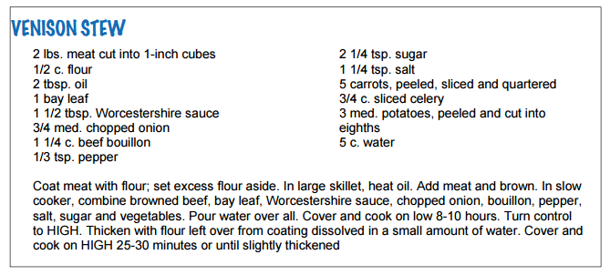
What is the total amount of ingredients used in the recipe above, in cups? In Tablespoons?
c. = Cups
tbsp = Tablespoon
tsp. = Teaspoon

2 Cups = 1 lb
48 tsp = 1 cup
16 tbsp = 1 cup
3 med potatoes = 1 lb
1 onion = 1 c.

Cups: ______

