Medieval Law & Order
Name: Div: Date:

Read pg 56-58 in your supplemental booklet to answer the following questions:

- Explain how medieval law is both similar and different from modern Canadian law.

- Describe the following, and why people thought they would prove someone’s innocence:

  - Trial by Ordeal

  - Trial by Battle/Combat

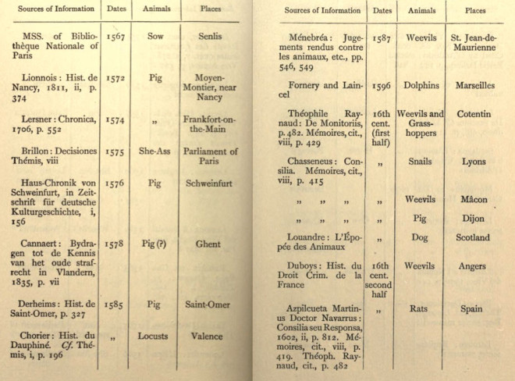
Medieval Methods of Proof:
- Ordeals

- Combat

- Compurgation
(Left) List of animals put on trial and executed for their crimes

- Fill in the following table:
 | Manor Court | Royal Court | Church Court
People Tried?
Types of crimes the court tried?
Who decided the case? |  | The King
Possible punishments?
Pros?
Cons?

- Explain what happened with Thomas Becket, and how it shows fight for power between kings and the church.

