METAL

 | Gold / Or  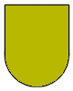  Understanding, respect, virtue and  majestic -generosity | Silver - White / Argent  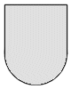  Cleanliness, wisdom, innocence,  peace and joy

COLORS

Red / Gules  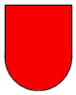  Eagerness to  serve his country. Warrior & martyr | Blue / Azure  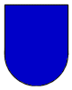  Steadfastness, strength & loyalty | Black / Sable  Grief and  resistance | Green / Vert  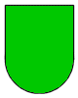  Freedom, beauty, joy, health,  and hope | Purple  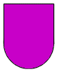  Majesty, justice  and sovereignty | Orange  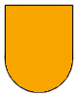  Rewarding Ambition | Maroon  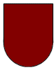  Victorious - Persevering  in the battle

Examples of heraldic shield divisions

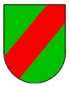  Defense or protection | 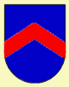  Protection | 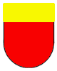  Rule and authority | 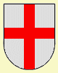  Faith and protection | 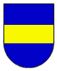  Military strips or  Belt of Valor

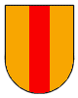  Military strength or bravery. | 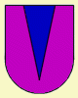  Stands for military strength  or fortitude. | 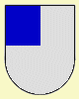  Honor | 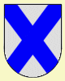  Protection
Dividing lines
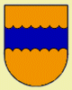  represents  Earth & Country | 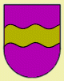  Represents  the sea or water | 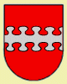  Represents  clouds and air | 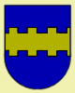  Represents fire, or  the walls of a fortress  or city | 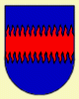  Represents the radiation  the sun. symbolizes  also fame and glory
Heraldic Symbols
Acorn  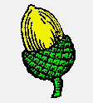  The character of the acorn is  independence, strength and  antiquity represents | Ant  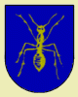  Symbol of the ant traditionally meant one who the workers a strong, wise and Foresighted in all his affairs. | Angel  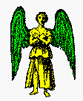  The angel is always in full view, shown with the wings extended and upright. He is the bearer of the good news as well as dignity, honor and glory.
Antler  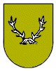  Antlers represent strength and fortitude. | Anvil  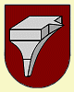  The anvil - symbol of honor | Arm  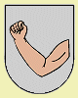  The arm represents an industrious person, someone who believes in hard work
Armored Arm  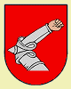  Represents a person who served as a leader. | Arrow  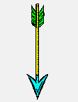  Arrows symbolize readiness for battle. | Buckle  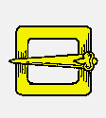  The buckle is self-defense  and protection,
Bear  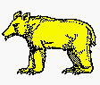  Emblem of strength, cunning and cruelty in the protection of the clan. A bear is also a symbol of healing and personal health and bravery. | Boar  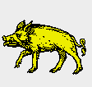  The boar is the symbol of courage.  a champion with the wild animals,  he is a fierce fighter. | Boar Head  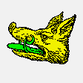  Represents the restaurant or one which is hospitable.
Bay Leaves  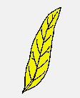  In antiquity it was a sign of peace  Seen and stillness. A symbol of  victory and glory, especially after one  long, inner struggle. | Bee  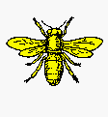  The bee is a sign of industry, creativity, wealth, diligence and eloquence. The Egyptians used it as a symbol of royal power. | Bird  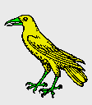  Birds of all species (blackbirds,  thrushes, red bird) provide peace  and affection for the home and family.
Bull  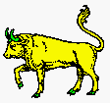  A bull, also known as an ox,  represents bravery and generosity,  The horns are the strength and fortitude. The calf is a old heraldic tradition with the properties of patience, humility and  sacrifice connected. | Cat  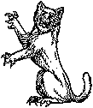  A symbol of liberty, vigilance and courage. | Camel  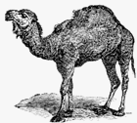  The camel symbolizes temperance, patience and perseverance.
Castle  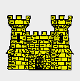  The castle symbolizes strength and vigilance, as well as at home and safety. | Crown  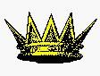  It is symbol of victory, and a visible sign of success. It is the ultimate level of rank, power, and honour. | Crescent Moon  The crescent moon is a symbol of hope to greater honor, or a second son.
Dog  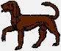  The dog is the symbol for courage vigilance and fidelity fidelity. | Dolphin  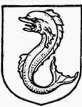  It represents swiftness, diligence,  charity and love | Dove  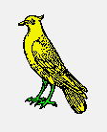  The dove is a symbol of peace and purity.
Dragon  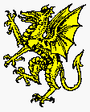  A dragon with his sharp eye, is the  guardian of treasures. He is also  the bravest of all the creatures | Duck  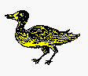  Ducks can deceive their enemies in many ways by flying, running, swimming or diving. Therefore, they are a symbol of a person of many resources. | Elephant  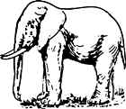  A symbol of huge strength and stature,  wisdom, courage, happiness, royalty and ambition.
Eagle  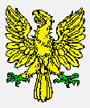  The eagle symbolizes a man of action, a person of high intellect, ingenuity, repartee, and quick comprehension. | Two-headed Eagle  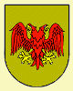  Symbolically, a protector,  unity of two forces. | Fox  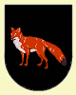  The fox is a symbol for a person of his  wisdom, ingenuity, wit and wisdom for his use own defense.
Falcon or Hawk  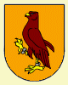  The falcon or hawk is someone who eagerly in the pursuit of an object and is not rather dormant until the goal was achieved. | Feathers  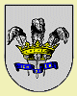  Feathers are a very common symbol in heraldry, which is not surprising when you consider that frequently during a tournament the helmet with feathers was decorated. Means willing  obedience and serenity of mind. | Fish  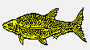  Fish are symbols of bravery and steadfastness. They are also symbols of economy, science and symbols of a genuine, generous spirit
Fleur-de-lis  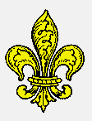  Provides a stylized form of the lily. It is  the floral emblem of France and is known as the "flower of light." It may also include the sixth son. | Grapevine  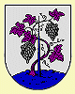  Represents strength and  lasting friendship | Griffin  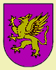  Symbolizes bravery, strength, alertness and endurance
Goat  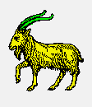  Symbol of practical wisdom and an emblem of a man who wins through diplomacy rather than war. | Hand  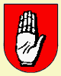  Credibility, sincerity and justice. | Armored Hand  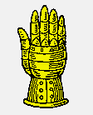  Armored gloves symbolize a  armed man who is ready to wage war.
Horse  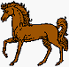  The horse is a symbol of speed, intelligence and masculinity. | Harp  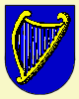  Represents a well-composed person of tempered judgment. | Heart  Symbolizes sincerity, a person telling the truth, and as a symbol of goodness and charity.
Helmet  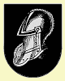  It represents wisdom, security, even strength, protection, and invulnerability | Knight  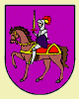  A knight on horseback represents a warrior. | Key  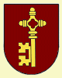  The key is a symbol of knowledge.  Two keys crossed is the symbol of St. Peter, the symbol of the pope.
Lamb  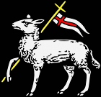  A symbol of faith, innocence, gentleness, purity and resolute spirit. | Lion  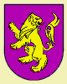  The lion is the emblem of undying courage, and a valiant warrior. | Mermaid  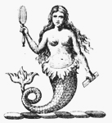  A symbol of eloquence.
Mountain and Rocks  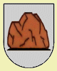  Hills provide security, shelter  and protection | Nail  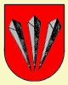  Passion - pins symbolize remembrance and sorrow | Owl  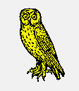  The owl symbolizes vigilance  and repartee.
Peacock  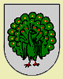  The peacock is a symbol of beauty, power and knowledge. | Rat  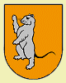  Symbolizes one who is cunning and determined. | Raven  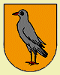  Is a collector of bright objects is, the raven as a symbol of knowledge.
Ram  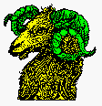  The ram is a symbol of authority  and leadership | Rose  The rose is a symbol of hope, joy,  grace, and beauty; it is also a sign of the seventh son. | Rooster  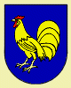  It is a sign of hero, one who fought with courage and perseverance.
Shell  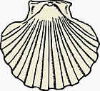  Symbolizes protection of providence. | Scale  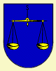  Scales are traditionally a symbol of fairness and justice. | Squirrel  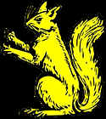  A symbol of thrift, caution and conception
Swan  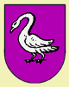  The Swan is the ensign of poets and  musicians. It symbolizes perfection  beauty and grace. It is also light, love,  grace, sincerity and perfection. | Sword  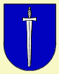  The sword is the symbol of the military  honor. It is also a symbol of power and freedom. The sword (especially with flame) is also a symbol of purification. | Snake  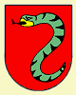  A symbol of wisdom, defiance, fertility, and renewal. Because of its forked tongue, it was also associated with lightning and the sun. Snakes represent knowledge.
Stag  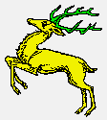  He is also a symbol of peace and harmony - a person of the policy. | Thistle  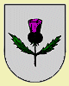  The thistle is an ancient heraldic symbols of pain and suffering | Tower  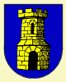  The tower is an emblem of grandeur, defense, and an individual’s fortitude.
Unicorn  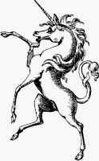  A symbol of purity and virtue. | Tree  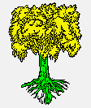  Antique and symbolizes strength. In Ireland, the noblest of oak trees. | Wings  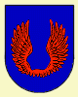  Symbolizes swiftness and protection.
Wheat Sheaf  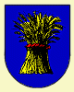  The wheat sheaf is the meaning of  abundance and hope | Wolf  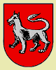  The wolf means valor and guardianship. wolves were considered to be cruel and merciless | .

