Multiplying Integers
Name: Div.: Date:

When you have a positive and a negative you move towards the negative.
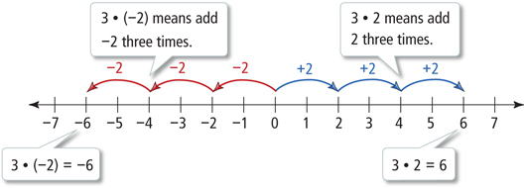

Multiplying by a negative makes it go in the opposite direction/flips the sign of the value you are multiplying (you stumble back three steps [negative] twice, while facing the negatives)
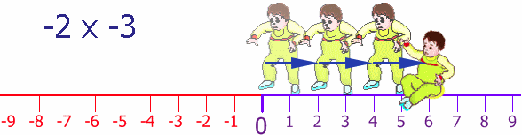

When multiplying/dividing integers you do the math normally and just determine the sign based on this rule:
- Odd number of Negatives = Negative
  - E.G. $\left(-2\right)\left(-3\right)\left(-2\right)=(-12)$ $\left(-2\right)\left(+3\right)\left(+2\right)=(-12)$

- Even Number of Negatives = Positive
  - E.G. $\left(-2\right)\left(-3\right)\left(+2\right)=(+12)$ $\left(+2\right)\left(+3\right)\left(+2\right)=(+12)$

Diagram using a number line:
- $\left(-3\right)\left(2\right)=(-6)$
- $\left(-3\right)\left(-2\right)=\left(+6\right)$
- $\left(-3\right)\left(-2\right)=\left(+6\right)$
- $\left(-3\right)\left(-2\right)=\left(+6\right)$

Diagram using tiles:
- $\left(-3\right)\left(+2\right)=(-6)$
- $4\left(-2\right)=\left(-8\right)$
- $\left(-3\right)\left(-2\right)=\left(+6\right)$
- $\left(-2\right)\left(-4\right)=\left(+8\right)$

Identify the missing sign:
- $\left(+6\right)\left( 7\right)=(+42)$
- $\left(-6\right)\left( 7\right)=(+42)$
- $\left( 2\right)\left( -3\right)=(-6)$
- $\left( 2\right)\left( -3\right)=\left(+6\right)$
Identify the missing value:
- $\left(-3\right)\left( \right)=\left(-9\right)$
- $\left(+9\right)\left( \right)=\left(-27\right)$
- $\left(-3\right)\left( \right)=\left(-15\right)$
- $\left( \right)\left( -5 \right)=(+35)$
- $\left( \right)\left( -6 \right)(-1)=(+12)$
- $\left( +3\right)\left( \right)(-4)=(-36)$

Find the Product:
- $-3\left(-4\right)\left(+5\right)=$
- $-3\left(+2\right)\left(+3\right)=$
- $3 x 7 x \left(-2\right)=$
- $-2 x 3 x \left(-5\right)=$
- $\left(-3\right)\left(-2\right)\left(-3\right)=$
- $\left(-4\right)\left(+2\right)\left(+6\right)=$
- $\left(-3\right)\left(-2\right)\left(+7\right)=$
- $\left(-2\right)\left(-2\right)\left(-4\right)\left(-1\right)=$
- $\left(-3\right)\left(-2\right)\left(+3\right)\left(-2\right)=$

- The temperature in Quebec City was 3ºC at midnight. The temperature dropped an average of 2ºC/hr until 05:00.
  - What was the total temperature change?
  - What was the temperature at 05:00?

- Copy and complete the following statements:
- The product of three negative integers is always…
- The product of two negative integers is always…
- The product of two positives and one negative integer is always…

- Decide whether each statement is always true, sometimes true, or never true. Explain.
- The product of a non-zero integer and its opposite is the same as the square of that integer.
- Multiplying a non-zero integer by itself gives a larger integer

