Integer Review
Name: Div.: Date:

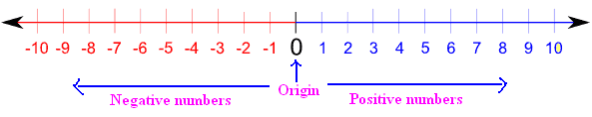
More/ Larger/ Above/Over/etc.
Less/ Smaller/Below/Under/ etc.

Describe the following using an integer number:
- 22ºC above zero
- 9ºC below zero
- 567m above sea level
- 234m below sea level
- Loss of 7 points
- Win by 8 points
- 3 over par
- 7 under par
- 11 floors up
- 3 floors down

State the opposite of each integer:
- $-7$
- $+6$
- $-2$
- $5$

State the next larger integer:
- $-7$
- $0$
- $-4$
- $2$

State the integer that is 1 less than each of the following:
- $-1$
- $0$
- $-3$
- $1$

Graph the following integers on a number line (Leave any other values blank):
- $-1, +2, -3, 0, +3$
- $-2, +6, -1, +4, +2$
- $-4, +1, -5, -2, -1$
- $-3, -2, -5, 0, +2$

Compare using <,=, or > to make each statement true:
- $5 3$
- $-6 -7$
- $+2 2$
- $-8 -7$

Write the integers from largest to smallest:
- $-2, 0, -3, 5$
- $-15, 18, 14, -12$

Write the integers from smallest to largest:
- $0, -1, 3,-2$
- $4, -2, 0, -3$

Write the integer that is:
- $5$ less than $7$
- $2$ less than $-3$
- $3$ less than $1$
- $4$ less than $-6$

- Give four real world examples of the use of Integers:

- Pattern Work:
Aziza and Efra are twin babies.
  - Determine the sum and product of their ages when they are 1, 2, 3, and 4 years of age.
  - Determine the quotient of the product over the sum at each of the ages in question 1.
  - Describe the pattern in the quotients from the previous question.
  - Use the pattern to predict the quotient for their ages at:
    - 10
    - 15
    - 25
  - Hold old will the twins be when the quotient is:
    - 15
    - 25
    - 30

