Place Value: Standard, Written, and Expanded Form

Name: Date:

- Each Number is made up of smaller numbers added together; this is shown in the Expanded Form.
  - For the decimal places you must put a zero in every place value before the value you are writing
    - 34.578 = 30 + 4 + 0.5 + 0.07 + 0.008

- When completing a cheque (i.e. rent) you also write out the Written Form of the number, which is done by writing out the numbers followed by their place value (two hundred fifty six million).
  - Place a comma to differentiate between each billions, millions, thousands, ones, and decimal values; but use an and to indicate a decimal
    - Ex. Three billion, four hundred twenty five million, five hundred thousand, six hundred twelve, and seven one hundredths
    - 3, 425, 500, 612 . 07

  - Write the decimal numbers from their final place value to the decimal as though it is greater than one, then finish with the final digit’s place value to show that it is a decimal place.
    - 3.0019 Three and nineteen Ten Thousandths
      - Reason = 0.0019 is basically the number nineteen, and the nine is in the ten thousandths place value.

Ten Thousands | Thousands | Hundreds | Tens | Ones . | Tenths | Hundredths | Thousandths | Ten Thousandths
x10000 | x1000 | x100 | x10 |  | ÷10 | ÷100 | ÷1000 | ÷10000
Place Value: Standard, Written, and Expanded Form

Name: Div.: Date:

Fill in the following tables to create an addition problem where each digit of the solution is its own number that when all added together make the number at the bottom.
3 | 5 | 7. | 1 | 5 | 9
7 | 2 | 3. | 0 | 4 | 3
6 | 0 | 9. | 2 | 0 | 6
1) 2) 3)

6 | 0 | 4. | 5 | 0 | 9
9 | 9 | 0. | 6 | 4 | 9
4) 5) 6)
8 | 7 | 6. | 4 | 2 | 3

Standard Form | Written Form | Expanded Form
 | Three Hundred Fifty-Six and Seven Tenths
473.69
 |  | 400 + 70 + 8 + 0.1 + 0.02
 | Eleven Hundred Fifty and Twenty-one Thousandths
 | Five Thousand, Sixty-Nine and Eight Hundred Five Thousandths
9,184.7
 | Seventy Nine Thousand, Eight and Seven Tenths
 |  | 40,000+ 9,000+ 700+ 60 + 0.9 + 0.09
1,005.09
3,456.002
 |  | 50,000 + 700 + 50 + 8 + 0.7 + 0.04
 | Twenty-Eight Thousand, Five Hundred Six and Nine Hundred Seventeen Thousandths
 | Sixty-Eight Thousand, Two Hundred One and One Hundred Four Thousandths
 |  | 20,000+ 9,000+ 500+ 6 + 0.2 + 0.02 + 0.002
 | Fifteen Thousand Nine Hundred Forty-Eight and Five Thousandths
68,776.219
Complete the following cheques:
- $950 for September Rent to Aaron Maxwell B) $408.44 to B.C. Hydro for November/December C) $875.49 to Island Plumbing for Water Tank

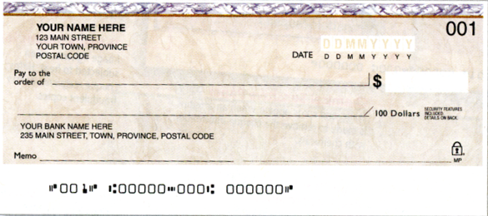

Complete the following cheques:
- $187.45 for Bicycle to Aaron Maxwell E) $246.88 to Cornerstone Property for Dec. Strata F) $3489.97 to Mike Holmes for Dodge Caravan

