Fitness Testing Design
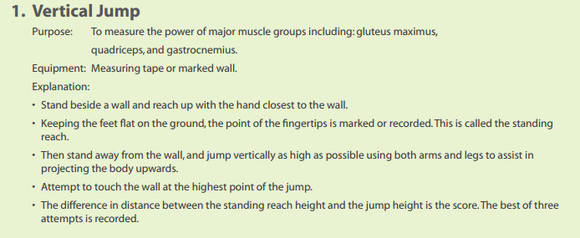

2. Chin Ups
Equipment: Bar hanging from 6 feet above the ground so students aren’t able to touch the ground when fully extended.
Explanaition:
- Using a chair, get a good grip on the bar (bar should be held in palm of the hand with fingers wrapped around) palms facing yourself
- Hang from the bar with arms fully extended (legs may be extended or held up at 90 degree angle)
- Pull yourself up to the point that your arms are fully flexed and your elbows are at the side of your body (bar should be around chin height at this point) as many times as possible.
  - If you begin to swing/kick your legs and or your chin doesn’t make it to the bar you are finished.

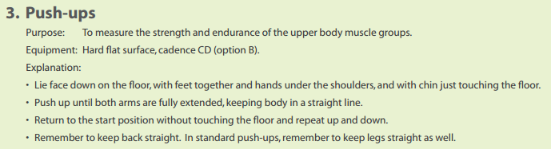
Do as many pushups, in a row, as possible.
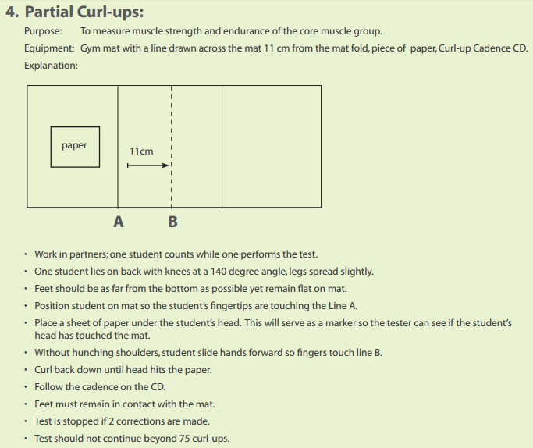
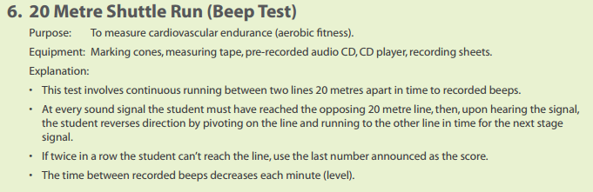
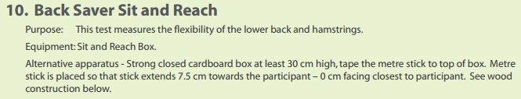
Testing Standards

The numbers represent the level attained by the student.

Boys
Age | CI | Good | Very Good | Excellent
10 | < 3/5 | 3/6-5/5 | 5/6-8/1 | > 8/1
11 | < 3/6 | 3/7-5/8 | 5/9-8/6 | > 8/6
12 | < 3/8 | 4/1-6/4 | 6/5-9/3 | > 9/3
13 | < 4/2 | 4/3-6/9 | 6/10-10/1 | > 10/1
14 | < 4/5 | 4/6-7/4 | 7/5-10/9 | > 10/9

Girls
Age | CI | Good | Very Good | Excellent
10 | < 3/1 | 3/2- 4/7 | 4/8-6/8 | > 6/8
11 | < 2/8 | 3/1- 4/8 | 4/9-7/1 | > 7/1
12 | < 2/8 | 3/1-4/9 | 5/1-7/3 | > 7/3
13 | < 3/1 | 3/2-5/1 | 5/2-7/5 | > 7/5
14 | < 3/1 | 3/2-5/1 | 5/2-7/6 | > 7/6

HRR
(HR after exercise – HR 2min later)
Excellent | > 66
Very Good | 50-65
Good | 23-49
Could Improve | < 22

Push-ups (Boys) Push-up (Girls)
 | 10yr | 11yr | 12yr | 13yr | 14yr |  |  | 10yr | 11yr | 12yr | 13yr | 14yr
E | 19 | 23 | 23 | 26 | 30 |  | E | 20 | 20 | 22 | 22 | 24
VG | 16 | 19 | 19 | 24 | 27 |  | VG | 15 | 15 | 16 | 16 | 17
G | 12 | 14 | 14 | 16 | 17 |  | G | 10 | 10 | 12 | 12 | 12
CI | < 12 | < 14 | < 14 | < 16 | < 17 |  | CI | < 10 | < 10 | < 12 | < 12 | < 12

Curl Ups (Boys) Curl Ups (Girls)
 | 10yr | 11yr | 12yr | 13yr | 14yr |  |  | 10yr | 11yr | 12yr | 13yr | 14yr
E | 50 | 51 | 56 | 58 | 59 |  | E | 47 | 50 | 52 | 51 | 51
VG | 40 | 41 | 46 | 48 | 49 |  | VG | 39 | 40 | 41 | 41 | 42
G | 34 | 36 | 38 | 40 | 42 |  | G | 32 | 34 | 36 | 35 | 35
CI | < 34 | < 36 | < 38 | < 40 | < 42 |  | CI | < 32 | < 33 | < 36 | < 35 | < 35

Sit & Reach (Boys) Sit & Reach (Girls)
 | 10yr | 11yr | 12yr | 13yr | 14yr |  |  | 10yr | 11yr | 12yr | 13yr | 14yr
E | 21 | 21 | 22 | 23 | 26 |  | E | 22 | 24 | 27 | 30 | 31
VG | 16 | 16 | 16 | 17 | 20 |  | VG | 18 | 19 | 21 | 23 | 25
G | 12 | 12 | 13 | 13 | 15 |  | G | 15 | 16 | 17 | 18 | 20
CI | < 12 | < 12 | < 13 | < 13 | < 15 |  | CI | < 15 | < 16 | < 17 | < 18 | < 20
In centimeters In centimeters

 | Standard Levels | 9-11yr Boys | 12-14yr Boys | 9-11yr Girls | 12-14yr Girls
Vertical Jump | Excellent  Very Good  Good  Could Improve | 40cm  34cm  28cm  <28cm | 50cm  44cm  30cm  <30cm | 40cm  36cm  26cm  <26cm | 45cm  40cm  28cm  <28cm

 | Chin Ups
 | Boys | Girls
Excellent | 6+ | 4+
Very Good | 4 | 3
Good | 2 | 2
Could Improve | 0 | 0

