European Explorers Cards

Name: Div: Date:

You will find the important information for each explorer and organizing your information onto the cards provided.

List of Explorers
Vasco da Gama | Christopher Columbus
Ferdinand Magellan | Francisco Pizarro
Bartolomeu Dias | Hernando Cortez
Samuel de Champlain | Henry Hudson
Jacques Cartier | John Cabot

CRITERIA:
- Who? Name, Image, Brief Bio
- Where? Label the routes of their expeditions on the map
- When? Create a Legend of the dates of their expeditions on the map
- Why? Did they go on their voyage? What were they looking for? (Gold? China? Etc.)
- What? What did they discover, or do that is impressive or important?
- Interesting Fact?

Marking
Total: 5 x 10 cards = 50 marks
5 | All of the criteria is included, is accurate, and appears to be incredibly well researched.
4 | All of the criteria is included, is accurate, and appears to have researched beyond requirements.
3 | All of the criteria is included, and is accurate.
2 | Some of the criteria is missing, or has several inaccuracies.
1 | Multiple criteria are missing and or inaccurate.
0 | Not Included

Reason for Voyage(s):
Discoveries/Result of Voyage(s):
Interesting Fact:
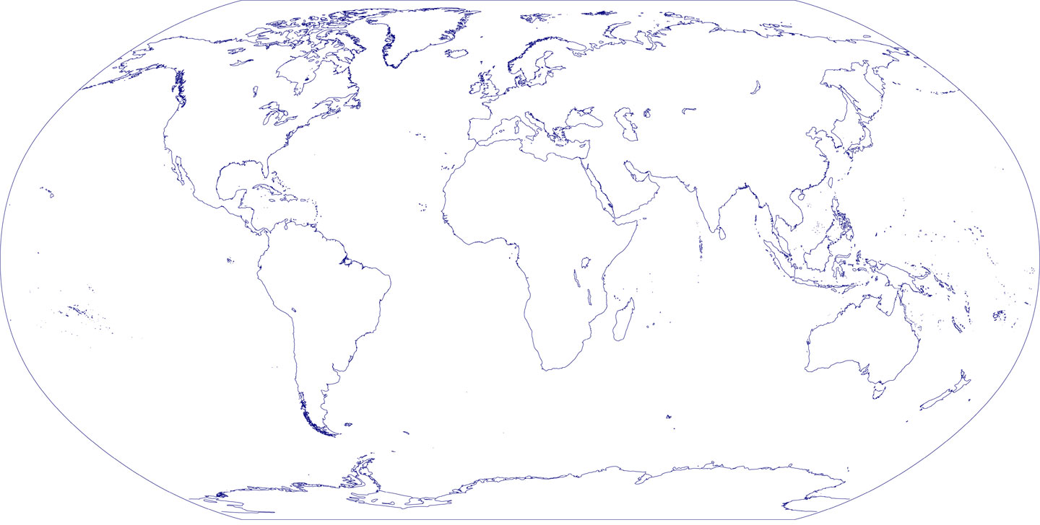
Year(s) of Voyage(s):

Reason for Voyage(s):
Discoveries/Result of Voyage(s):
Interesting Fact:
Year(s) of Voyage(s):

